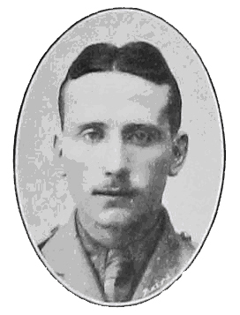

Thomas Fletcher Brown

1894 - 1915

"Tom"

The following pages document the life of Thomas Fletcher Brown from his birth in Belfast to his death as a Second Lieutenant in the The Manchester Regiment during the Gallipoli campaign in 1915.

The research has been carried out by his nephew, Michael Brown, and any comments can be forwarded to mjf-brown@ntlworld.com

(Where appendices are mentioned in the document they can be opened by Ctrl + Click - then to return to the place you were in the document key Alt + Left Arrow.)

Introduction

On 25 April 1915 a military landing was carried out by the Allies on the Gallipoli Peninsula which forms the northern shore of the Dardanelles. The resultant attempts to hold and extend the area won in this landing were a failure - commonly termed as one of the classic failures of military history. On 9 January 1916, just over 8 months later, the Peninsula was evacuated. Two evacuations were carried out on December 19th to December 20th without a single casualty. The evacuation of Helles (where Tom had been killed) occurred on January 8th to January 9th, again with no loss of life. Thus the campaign ended with two successes which have been described as masterpieces. The campaign lost the Allies 46,000 lives, and the Turks an estimated over 200,000 lives. Dead and wounded totalled nearly half a million.
In this brief history relating to Tom, three main reference sources have been used:

- Firstly, "The Manchesters", published by The Picture Advertising Co Ltd, London, 1916. (referenced throughout as "The Manchesters").

- Secondly, "The Manchesters in the East, 1/7th Manchester (Volunteer) Battalion", by Major G B Hurst, published by Manchester University Press, 1918. (referenced throughout as "The Manchesters in the East").
- Thirdly, "I Remain, Your Son Jack - Letters from the First World War" by J.C.Morten and Sheila Morten, published by Sigma Leisure, 1993.( A collection of letters from Private Jack Morten, No 2393, D Company, 1/7th Manchesters.) (referenced throughout as "I Remain, Your Son Jack").
The significance of these books in researching Tom's military "career" is considerable. All were written at the time of, or soon after, the events described. "The Manchesters" was written by "G.L.C" in 1916 and thanks "all those Officers of the Regiment who have so kindly helped me to gather the details together".
Major G B Hurst was an officer in the 1/7th Battalion and his 1918 account of the Battalion's journey up to that point is unlikely to be inaccurate in its detail.
Private Jack Morten was not only in the 1/7th Battalion with Tom, but (as it will later be shown) was most likely in the same Company as Tom. (Jack was later Commissioned as a 2/Lieutenant in the 1/7th Battalion.) His letters home describe events within days of their happening.
These three sources detail the same events with almost total agreement. They are therefore considered to present an accurate picture of what happened to the 1/7th Battalion up to, and during, Gallipoli. More specifically they describe the events impacting on the Company Tom was in, and hence Tom himself.
Later, when documenting the lead-up and circumstances of Tom's death, Jack's account of his own situation is presented at some length. It describes the dreadful circumstances Jack had to deal with. Jack survived, but Tom suffered the same awful circumstances and was sadly killed in the same action.
By concentrating on Tom, only selected parts of these books have been used. However, more generally they are incredibly informative accounts of the story of the men of the 1/7th Battalion The Manchester Regiment and are well worth reading.
Where other than the three main sources are used, they are also referenced.
The final Appendix 17 is a "timeline" which puts all the events described in datal order.

From Belfast to 1/7th (Territorial Force) Battalion, The Manchester Regiment.

Tom was born on 5 July 1894. His parents were William and Lizzie. He had sisters Isabella (later Isa) and Lizzie (later Lily) and brother John. There is a possibility that there were 2 deceased brothers, both William.

He attended the Royal Belfast Academical Institution (RBAI or Inst) from 1908 and resided at 204 Shankill Road, Belfast.

The 1911 census (Appendix 1) records the family at 204 Shankill Road on 2 April 1911 as being:

- William, 42 years, shipbuilding machinist
- Lizzie, 41 years
- Thomas, 16 years, apprentice linen manufacturer
- Isabella, 15 years, scholar
- Lizzie, 9 years, scholar
- John, 3 years.

Despite father William being recorded as "shipbuilding machinist", the House and Building Return of the census (Appendix 2) shows the house at number 6 on the return as "Draper Shop and Private Dwelling".

The Belfast and Province of Ulster Directory for 1900 (Appendix 3) under the listing of Drapers records "Brown Wm 202, 204 Shankill Road". The reference to " 202 Shankill Road" is a mystery.

On 28 September 1912 ("Ulster Day") father William signed the Ulster Covenant (for men) at Belfast City Hall (Appendix 4), and mother Lizzie signed the Declaration (for women) at Albert Hall (Appendix 5). There is no record of Tom, aged 18 years, signing the Covenant (any male over the age of 16 could sign). However, in a reference to Tom in "The Manchesters in the East" it says ".....Lieut. T.F. Brown, a gallant boy, who, in the happier days of the threatened war in Ulster, had served in the West Belfast Loyalist Volunteers."

Tom joined the Belfast University Contingent Officer Training Corps (later Queen's University Officer Training Corps) (OTC) on 7 May 1913 aged 18 years. The OTC records show that he had a commercial occupation, although it does not specify what it was. A reasonable conclusion from census and OTC records is that Tom left school at Inst at 16 years of age to train as an apprentice linen manufacturer. Although not a university student, he was able to join the University OTC because of pre-war recruiting arrangements that allowed suitably educated (possibly an interview process) volunteers to receive Officer training.

In July 1913 he attended an OTC camp at Ballykinlar, County Down. A postcard he sent to his parents is copied at Appendix 6.

The records show that Tom served in the OTC until the day before being commissioned into the 1/7th (Territorial Force) Battalion, The Manchester Regiment on 2 September 1914. His army number recorded in the OTC register is 393. The London Gazette record of his Commission is shown at Appendix 7.

The Manchester Regiment

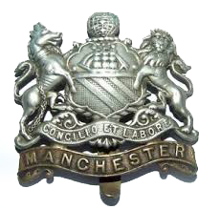

The Manchester Regiment came into being on 1 July 1881 by the union of the 63rd (West Suffolk) and 96th Regiments of Foot.
During the 1914-18 war The Manchester Regiment raised 45 battalions of which 29 served overseas. They won nearly 80 battle honours on the Western Front, Gallipoli, Italy, Palestine, Mesopotamia and in other theatres and earned 11 Victoria Crosses.
The Regiment lost nearly 14,000 men killed in the First World War.

The 1/7th (Territorial Force) Battalion
The Manchester Regiment
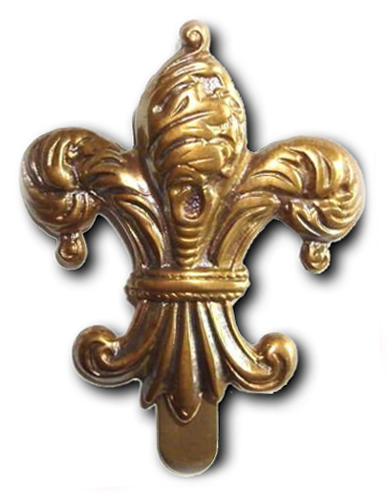
The fleur-de-lis above - a stylized lily - was the cap badge of the the 1/7th (Territorial Force) Battalion The Manchester Regiment. It commemorates the capture of French regimental colours by their predecessors, the 63rd (West Suffolk) Regiment of Foot, during the Invasion of Martinique in 1759.
The Battalion was raised as a result of a meeting of Manchester Citizens, held in the Manchester Town Hall on 1 December 1859, the Mayor presiding. The first title of the Battalion was "The 3rd Regiment of Manchester Volunteers" and the Headquarters were at 75, Bridge Street.  In February 1860, the title was changed to 40th Lancashire Rifle Volunteers. In September 1880, the title became 16th Lancashire Rifle Volunteers.  In August 1888, the title was again changed to 4th Volunteer Battalion, The Manchester Regiment, as part of the scheme linking the auxiliary forces with the regular regiments.  On the inauguration of the Territorial Force in 1908, the Battalion was designated 7th Battalion (Territorial Force) The Manchester Regiment.  The Headquarters in Burlington Street, having been built and presented to the Battalion by the Earl of Ellesmere, who was in command, were occupied in September 1884.  In 1900-1901, the Battalion furnished voluntary contingents of about 150 Officers and men to the forces engaged in the campaign in South Africa.  The 1/7th Battalion was mobilised on 5 August 1914, and immediately volunteered for General Service. On 20 August they marched out to the Camp at Hollingworth Lake, Littleborough near Rochdale. The personnel were asked to volunteer for overseas service and 26 Officers and 808 men, roughly 90% of the 1/7th Battalion, volunteered for Imperial Service. (The deficiencies were made up of men from the National Reserve and other re-enlistments. The 'home service' men formed the cadre of duplicate units, intended to train the rush of volunteers at the drill halls. These would form the Divisional Reserve.) The Imperial Service volunteers of the 1/7th Battalion were to form part of the East Lancashire Territorial Division and embarked at War strength at Southampton on 10 September 1914. It proceeded to the Sudan, less one Company, which was divided between Alexandria (Egypt) and Cyprus.  (It is assumed that Tom, following his Commissioning on 2 September 1914, joined the Battalion at the Camp at Hollingworth Lake and embarked from Southampton on 10 September).  At the beginning of the First World War the Infantry were organised into Divisions, Brigades and Battalions:  Infantry Division  │  3 x Infantry Brigades  │  4 x Infantry Battalions to each Brigade (total 12)  To see a more detailed breakdown of Infantry Divisions, Brigades and Battalions (and Companies and Platoons) see Appendices 8 and 9.  In 1914 the East Lancashire Territorial Division was one of fourteen Infantry Divisions and fifty–three mounted Regiments called the Yeomanry which made up the Territorial Force. Lord Kitchener, the Secretary of State for War, described these Divisions and Regiments of mainly white–collar workers as "a town clerk's army." Their junior Officers were trained at the Officer Training Corps set up at the universities and large public schools such as Eton and Harrow. Kitchener sent these forces to the peripheral campaigns - the Sudan, Mesopotamia, Egypt, and the Caucasus to release Regular British Army soldiers for duty on the Western Front because he thought these amateur soldiers "might not be able to hold their own" with the German Army.  The East Lancashire Territorial Division was the first Territorial Division to be sent overseas during the First World War. Its war station was intended to be Ireland, but due to its pacific state, the intended move did not materialise.  In April 1915 the East Lancashire Territorial Division was re-designated as the 42nd (East Lancashire) Division. It consisted of the 125th (Lancashire Fusiliers) Brigade, the 126th (East Lancashire) Brigade, and the 127th (Manchester) Brigade. The 1/7th Battalion were one of the four Infantry Battalions of the 127th (Manchester) Brigade, along with the 1/5th, the 1/6th and the 1/8th Battalions The Manchester Regiment, the127th Brigade Machine Gun Company, and the 127th Trench Mortar Battery.  In April 1915, the 1/7th Battalion left the Sudan to rejoin the 42nd Division in Cairo, and embarked at Alexandria in the early days of May for Gallipoli, taking part in the operations on the Peninsula, until the Mediterranean Expeditionary Force was withdrawn at the end of 1915.  Tom's subsequent journey will be documented in the following sections.  (1/7th Battalion events post Tom's death:  On returning to Egypt for the second time, the 1/7th Battalion was despatched to the Southern Section of the Suez Canal, and was engaged in the operations against the Turks in the Sinai desert until February 1917, when orders were received to proceed to the theatre of war on the western front in Europe. The Battalion embarked at Alexandria, and sailed on March 3rd, disembarking at Marseilles on 10 March 1917. The "Seventh" maintained its individuality throughout the war, and fought continuously until the Armistice was declared.  Under the reconstituted Territorial Army post-war organisation, the Battalion in 1921 numbered: Officers 25, other Ranks 512, but was ordered to amalgamate with the 6th Battalion in September, and on December 31st 1921 ceased to exist as a separate Unit.) | 548

The 1/7th Battalion Officers on Mobilisation
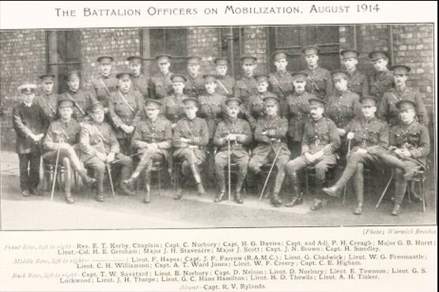
The Battalion Officers on Mobilization, August 1914
Photo: Warwick Brookes
Front Row, left to right—Rev. E.T. Kerby, Chaplain; Capt. C. Norbury; Capt. H.G. Davies; Capt. and Adj. P.H. Creagh; Major G.B. Hurst;
Lieut.-Col. H.E. Gresham; Major J.H. Staveacre; Major J. Scott; Capt. J.N. Brown; Capt. H. Smedley.
Middle Row, left to right—Unknown Rank and Name; Lieut. F. Hayes; Capt. J.F. Farrow (R.A.M.C.); Lieut. G. Chadwick; Lieut. W.G. Freemantle;
Lieut. C.H. Williamson; Capt. A.T. Ward Jones; Lieut. W.F. Creery; Capt. C.E. Higham.
Back Row, left to right—Capt. T.W. Savatard; Lieut. B. Norbury; Capt. D. Nelson; Lieut. D. Norbury; Lieut. E. Townson; Lieut. G.S.
Lockwood; Lieut. J.H. Thorpe; Lieut. G.C. Hans Hamilton; Lieut. H.D. Thewlis; Lieut. A.H. Tinker.
Absent—Capt. R.V. Rylands
The photograph shows the following breakdown of by rank:

1 x Lt Col
3 x Major
10 x Capt (including 1 x Royal Army Medical Corps)
13 x Lt or 2 Lt
1 x unknown rank
Chaplain

Total 28 Officers (+ Chaplain)

The textbook Battalion strength at the beginning of the First World War was:

1 x Lt Col (Battalion Commander)
1 x Maj or Capt (Adjutant)
4 x Maj or Capt (Company Commander)
4 x Capt (Company 2 i/c)
17 Lt or 2 Lt (16 x Platoon and 1x Machine Gun Section)

Total 27 Officers

Conclusion: At mobilisation on 5 August 1914 (Tom was later Commissioned on 2 September) the 1/7th Battalion The Manchester Regiment was over established in Officers - although it had an excess of Captains at the expense of Lieutenants and Majors. Some Captains must have been appointed as Platoon Commanders (normally Lieutenant or 2 Lieutenant). On or about 20 August 1914, 26 Officers volunteered for Imperial Service.

What Company was Tom in?

As identified earlier, on moving to the East in September 1914, the 1/7th Battalion was split with the main contingent going to the Sudan, and one Company divided between Alexandria and Cyprus. The Sudan contingent was further divided in different deployments within the Sudan. Given these different locations of elements of the Battalion, to follow Tom's journey it will be useful to identify which Company of the 1/7th Battalion he was in.

Photograph from "The Manchesters in the East":

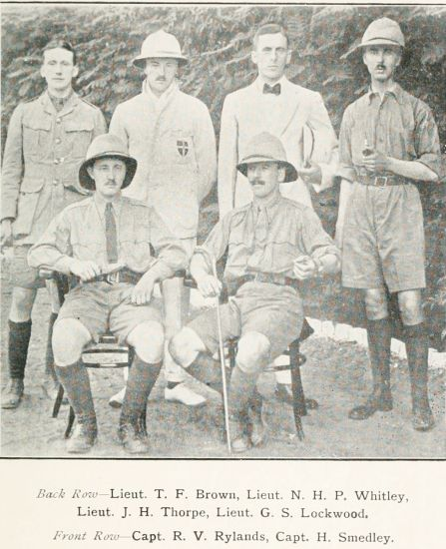

Back Row—Lieut. T.F. Brown, Lieut. N.H.P. Whitley, Lieut. J.H. Thorpe, Lieut. G.S. Lockwood.
Front Row—Capt. R.V. Rylands, Capt. H. Smedley.
This is clearly a photograph of the Officers of a Company (see Appendix 9). Four of the six participants are mentioned by Jack Morten in "I Remain, Your Son Jack":

- "Last night we had a lecture by Lieutenant Thorpe....."
- ".....then followed Captain Smedley with a song....."
- ".....but yesterday Lieutenant Whitley showed me a cutting from a Berlin Paper....."
- "We were rewarded for our pains by the Colonel telling Captain Smedley that the Barrack Rooms of "D" Company were the cleanest in the Barracks."
- "I had a lovely cup of tea yesterday: One of our officers, Lieut. Brown invited Eddy, Harold & myself to his room. It was quite a treat having tea with milk in it."
Jack Morten was definitely in "D" Company, 1/7th Battalion. It can be concluded with a reasonable degree of certainty that Tom was also in "D" Company.

From Southampton to Gallipoli

As identified earlier the 1/7th Battalion left the camp at Littleborough by train to Southhampton where they sailed on the ship Grantully Castle (Appendix 10) on the evening of 10 September 1914 as part of the East Lancashire Division. It was a convoy of fourteen transports and one ammunition ship, with HMS Minerva (Appendix 11) as escort. The convoy had 598 Officers, 18077 men, 5600 horses, 38 x 15 pounders, 12 Howitzers, 24 Machine Guns, 239 carts, 400 wagons and "an enormous amount of luggage". The ammunition ship carried 7 million rounds of ammunition.
The convoy passed Malta on 21 September 1914 and arrived at Alexandria on 25 September. B Company of the 1/7th Battalion and the rest of the East Lancashire Division disembarked here, and all of 1/7th Battalion less B Company sailed on to Port Said and the Suez Canal. The Battalion arrived in Port Sudan at 11am on 30 September 1914.
Extract from "The Manchesters in the East ":
"Next morning we started, with Major Boyle of the Egyptian Army Staff as a "cicerone," on the long railway track from the sea to Atbara and Khartum, past scattered villages peopled by staring Fuzzy Wuzzies with erect and luxuriant black hair, and across hot stretches of desert and rock. At a quarter past eleven on the morning of the 2nd October 1914 we arrived at Khartum (as spelt in the text quoted) North, where we detrained and were met by the Sirdar, General Sir Reginald Wingate, then Governor-General of the Sudan, and his Staff. We marched over the Blue Nile Bridge to the spacious British barracks, the only spot in the Sudan where the Union Jack flies unaccompanied by the flag of Egypt, and relieved the Suffolk Regiment. In the afternoon our band played them out of the cantonment, and we cheered them on the first stage of their long journey to the blood-stained battle-fields of Flanders."
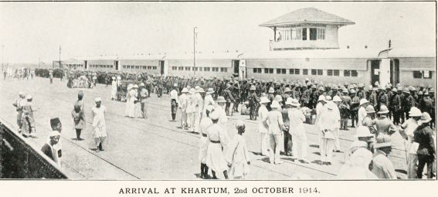
ARRIVAL AT KHARTUM, 2nd OCTOBER 1914."
The 1/7th Battalion, together with 60 Regular Army gunners at Khartoum Fort, constituted part of the British force then in the Sudan.
Extract from "The Manchesters in the East ":
" For some little time after our coming the normal social and sporting life of the small British colony at Khartum was hardly ruffled by the storm raging in Europe, and we gratefully enjoyed its warm-hearted hospitality."
The accounts, while including mention of guard duties at the Sirdar's Palace and the hospital, and training on the rifle range and trench digging, paint a picture of sport, concerts, horse racing at the Khartoum Racing Club and general "tourism".
Extracts from "The Manchesters in the East ":
"On the 30th October (Kurban Bairam day) the Manchesters saw the Sirdar bestow gaily coloured robes of honour on deserving chiefs. Everywhere were signs of economic progress. The cotton-growing plantations on the Gezira Plain, the ginning factory at Wad Medani, the numerous irrigation and public health works, the research laboratories of Gordon College, the industries of Khartum North and of Atbara, all bore the distinctive hall-mark of British Imperialism."
and:
"On the 19th November we were entertained at the Egyptian Army Officers' Club on the occasion of the Mohammedan New Year. On the 27th January 1915 the Prophet's birthday was celebrated with rapturous pageantry, and the Sirdar and Lady Wingate paid most impressive visits to the pavilions set up by the principal sheikhs and notables in front of the mosques at Khartum and Omdurman, while huge crowds of religious enthusiasts beat tom-toms and sang outside. We saw the Sirdar reviewing his Egyptian and Sudanese troops at Khartum, formally inspecting the schools, hospitals, barracks and prisons around Port Sudan, decorating veterans with medals, and addressing in every native dialect the political and religious leaders of the people."
and:
"Our officers interchanged visits with the officers of an Egyptian regiment quartered at Khartum, enjoying tea, music and speeches."
After six and a half months in Khartoum, the 1/7th Battalion left the Sudan by train for Port Sudan in two contingents on Friday 16 and Sunday 18 April 1915. It is believed D Company with Tom left in the first contingent. In Port Sudan they bivouacked in the open desert for the night. On Tuesday 20 April the Battalion embarked on the White Star Liner "The Suvic" and arrived at Port Suez on Thursday 22 April. There followed an eight hour train journey to Cairo. In Cairo the Battalion joined with all the other elements of the East Lancashire Territorial Division, now to be re-designated the 42nd (East Lancashire) Division. The 42nd Division then moved to Alexandria.
On 3 May 1915 the Battalion embarked at Alexandria in company with another Battalion of the Manchester Regiment on the ship SS Ionian (Appendix 12).
On the evening of Friday 7 May 1915 the 1/7th Battalion landed at "V" Beach, Cape Helles, Gallipoli. (See Appendix 14.)

1/7th Battalion, Gallipoli, 7 May to 27 May 1915

The landing on "V" Beach on 7 May was in the midst of the Second Battle of Krithia (6 - 8 May) in which the Battalion was held in Reserve. On 11 May the Battalion marched to the front line trenches where it had its "first baptism of fire" on the night of 12 May. (For a description of the trench system see Appendix 13). During this exchange the Battalion had its first casualties.
On 17 May the Battalion was relieved by the Royal Fusiliers and went back into Reserve.
The Battalion was sent forward to the reserve trenches again on 25 May, and then on the night of 27 May to the 2nd (or support) line of trenches. The following extracts describe these events.
Extract from "The Manchesters in the East ":
"The 42nd Division was soon in the midst of hard fighting, stormy weather and much privation. Casualties began early, though the first Battalion exploit under fire was happily bloodless. On the 9th May, 80 men were told off to fill water-bottles and carry them under fire over half-a-mile of broken ground to an Australian unit. They tracked cleverly across the moor, and were met by an eager Australian with the question: "Have you brought the water, cobbers?" On the 11th, the Battalion had a long, weary march to the front line. The trenches were full of water, and the gullies became almost impassable. On the 28th, Lockwood, our musketry expert, was severely wounded in the chest."
Extract from "The Manchesters":

"The Battalion's first experience of the fire trenches was on May 11th, 1915, when it relieved the Wellington Battalion, New Zealand Brigade. It received its baptism of fire on the nigh of May 12th, 1915. For two hours the whole of the guns on both sides, and the guns of the British and French Fleets bombarded the opposing lines of trenches. During an interval in this bombardment, a party of 100 officers and men who had gone out with rations, machine-guns, and also with the object of digging a communication trench, was caught in the open and suffered badly from shell fire, both from our own "Unders" and the enemy's "Overs." Some of the party were fortunate enough to scramble back to the face of the cliff they had just ascended, and so get cover. The others, however, had to lie flat in the open for about an hour. It was here that the Battalion first had any of its members killed, three men being killed, nine wounded, and one officer and one N.C.O. missing. Fortunately, the officer turned up the following day. His companion, however, was never seen again.

The Battalion's first charge against the enemy was made on May 13th, 1915, by "B" Company, who went forward, and along with the 89th Punjabis, gained about 50 yards of ground. The Battalion was relieved after about a week in the first line trenches, by the Royal Fusiliers, and went into Reserve.
The Battalion was sent up to the trenches again on the 25th May, and on the evening of the 26th relieved the 5th Battalion, Manchester Regiment."
Extract from "I Remain, Your Son Jack":

"Sunday May 8 1915

Dear Father,
I'm writing this in a dug-out on the Gallipoli Peninsular. I expect you got my PC from Alexandria, well I spent the whole day looking round & we sailed about 8 o'clock at night, down the Mediterranean & into the Gulf of Saros which we reached on Thursday.
On Friday night we landed on the Peninsular & marched straight away to where we now are. We bivouacked for the night & next morning we made a dug-out for ourselves. There are two of us in my little shanty, a fellow named Brockbank & myself & we are as snug as a bug in a rug.
Yesterday a terrific battle took place, the whole day through nothing but the roaring of guns could be heard, & by Jove, they don't half roar; what with our guns behind firing over us & the ones in front, it's like a terrific thunderstorm. I can tell you the last two days must have been like Hell to the Turks. A few of their shells dropped over us, but the only damage done was that Barratt got a small piece of shrapnel in his stem, it was so slight that immediately afterwards he was walking about as usual. So long as we keep in our dug-outs when the enemy's shells are about (which is not very frequent) we are as safe as eggs, & the Turks are in full retreat. We are here as a Reserve, the Sixth boys lines are just in front of ours, so we are all together again. I could give you a much longer & more descriptive version but I don't think it would be allowed to go through, in fact I'm not quite certain whether this will be passed but I'm writing it on the off chance.
I had a very good breakfast of bacon which I cooked & bully beef, & my partner is now preparing the dinner. I'm in the pink of condition & absolutely settled down to my new home. There is nothing to worry about as we're quite happy & the two of us work together A1.
I don't suppose I shall be able to write quite so regularly as I did from Khartum owing to any difficulties in the transport which sometimes arise on these occasions, but I will write as often as possible, if is only a PC. Of course money is no good here, but I expect they will deliver parcels to us, so anything in the nature of cocoa & something to eat will be an agreeable change. Give my best love to Mother, Patty, Lena & Tom & remember me to the usual crowd. Hoping you are as well as I am.

I remain, Your affectionate Son
Jack
PS I don't think I would mention anything to Barratt's Father about him being wounded unless he mentions it.

Monday May 17 1915

Dear Father,
Just a line to let you know that I'm in the pink. I received your letter in which you enclosed an introduction to Mr Del Sandys, but I'm sorry I shall not be able to take advantage of it having left Khartum four weeks ago. For the last week I've been in the trenches & have now come back to our dug-outs for a very welcome rest. When I've time I'll write you a longer letter, also I'll write Tom & Pat. Remember me to them. My address is The Mediterranean Expeditionary Force A few cigs will be very welcome.

Wednesday June 2nd 1915

I'm fairly in the thick of it now, but there is no earthly reason for you to worry yourselves about me, & if you can't read some of the words, don't get excited & talk about sending me to a writing school when I return, because really in my opinion I'm doing a most clever thing; in order to shade myself from the burning sun whilst writing this, I'm lying down in the trench on my back with my knees upright to form a writing pad.
I've seen Alan Preston out here, he's scarcely altered & is awfully young looking. He told me that all in his section had been killed & amidst heavy shrapnel fire he stuck at one of the guns & for this brave action they have made him a Lieutenant which he fully deserved.
Now for a brief description of what I've done. On Tuesday May 25th we left our bivouac for the Reserve Trenches, by Jove it was a journey. Our way was by the side of a quiet brook (in ordinary times), but owing to a very heavy rainfall this pretty little brook turned out to be a raging torrent through which we had to march for a mile, in some places it was waist deep. One part we came to cross on a very narrow strip of earth; here it was that J.C.M. (Jack Clarke Morten) must do something clever. I put my foot a shade to the right & went headlong into it & before I could pull myself out my rifle & spade were carried down by the strong current. Needless to say, I've not seen either since.
Whilst on the bank feeling my whereabouts, as it were, the boy next to me was shot in the arm, so after assisting to dress it I took his rifle & continued my weary way up the trench which was absolutely indescribable. Eventually I got to my part of the trench in spite of the slutch (slutch — very wet sticky mud) & water, had a good night's rest. Lt. Brown was next to me & shared his blanket with me, but I'm sorry to say that three days afterwards he was killed.
On Thursday 27th we left here at night for the 2nd line of trenches where we spent the night & the next day; by the way we were still up to the knees in mud & water"

The Circumstances of Tom's Death

On the night of 28 May, "B" and "D" Companies went forward from the support trenches and past the first line trenches to dig a new trench 100 - 150 yards beyond. Under a full moon the soldiers came under sustained attack from the Turks. The following descriptions leave little doubt that Tom was killed during this action, probably on the evening of 28 May, or possibly the early morning of 29 May.

(Records shown in following paragraphs show Tom to have been killed on 29, or more consistently 30 May. The 30 May does not fit with the first-hand accounts and is probably due to delay in "recording".).

Extract from "The Manchesters":
"On the night of May 28th, "B" and "D" Companies were ordered to go out 150 yards and dig a new trench, thus bringing our lines up to the Naval Division, which was on our right. "A" and "C" Companies were told off to dig the communication trenches between the new lines and the old. The digging was completed despite a galling fire at close range, though the price paid in officers and men was necessarily heavy, the casualties including Captain Rylands and 2nd-Lieutenant Brown killed. Lieutenant Whatley did great work during the first night's digging."
Extract from "I Remain, Your Son Jack":

"Now came the day which I shall never forget if I live to a centenarian. At dusk (28 May) we marched out in partners, me carrying a pick, the other a spade; each had his rifle, entrenching tool & 200 round of ammunition, & a sand bag half full. We doubled across the open to the first line of trenches. We now doubled in open formation (a long line of us) for over a hundred yards further on & had to dig ourselves in; however the moon was full & before we had dug a single spadeful the enemy discovered us & opened fire. It was most awful; we were lying flat on the ground with no cover except a bag half-full of sand which has been proved to be not bullet proof time & time again. The enemy kept up a fusillade of rifle fire & machine guns for at least the best part of an hour. I can't describe my feelings as I lay there, especially when four men on either side of my partner (Brockbank) & myself were wounded, crying out for help & we could do nothing to relieve them except put field dressings on the wounds.
It was no good lying there idle, so we set to work with our entrenching tools to dig ourselves in. Until we were 3 ft deep we had to work on our back, sides & tummy, then when we had enough cover we worked on our knees. All night long we worked & by dawn it was up to our shoulders, so we sat down, had some breakfast, then to work again. We were now able to use the pick & spade & in a very short time we were able to stand up it in, so we set about to join up to the next dug-out in which were Baty & Smith. I can tell you I never in my life dug harder. I used to think I had done well in Khartoum after I had dug a few feet on the Desert, but circumstances alter things somewhat. I'm such an adept with the pick & shovel now that when I come back we shall have no need for the Gardener.
We worked for two whole days connecting the various dug-outs thereby making a trench, & at night we had to keep a vigilant look-out, so after our two days were up & we were relieved we were all jolly thankful, & I've spent the greater part of my time since sleeping.
The General complimented the Battalion & said that it was the finest piece of work done since the landing, so the 7th have proved their worth. Of course like any Victory or advance in this Hellish War, one realises there is very little glory in Modern Warfare, especially when you see your comrades, boys with whom you have lived for 8 months, struck down by an enemy which you can't see. If wars have to be, I prefer the old time warfare where every man had a sporting chance & the best came out on top. I consider myself & the other boys who have come through unscathed jolly lucky."
Extract from "The Manchesters in the East":
"On the night of the 28th May the Battalion advanced, and B and D Companies dug themselves in under a full moon and in the face of the enemy, a platoon of C Company finishing the work on the following evening. In these operations fell Captains T.W. Savatard and R.V. Rylands, men of sterling character and capacity, and Lieut. T.F. Brown, a gallant boy, who, in the happier days of the threatened war in Ulster, had served in the West Belfast Loyalist Volunteers."

Where was Tom Killed?

Extract from "The Manchesters in the East":
"The advance of the 28th May was preliminary to the historic attack of the whole allied line from sea to sea, which had been timed for midday on the 4th June 1915 (the 3rd battle of Krithia). In this attack the Battalion advanced as the extreme right unit of our Infantry Brigade. On the left of the Manchesters was the 29th Division; on our right was the Royal Naval Division, and on their right were the French."

As with the system of rotating the four Battalions of a Brigade back from the front line trenches, to the support line trenches, to the reserve trenches, and to rest (see Appendix 13), the three Brigades in a Division were rotated from the trench lines to Divisional Reserve and to Rest/Training (and in some cases leave back to home):

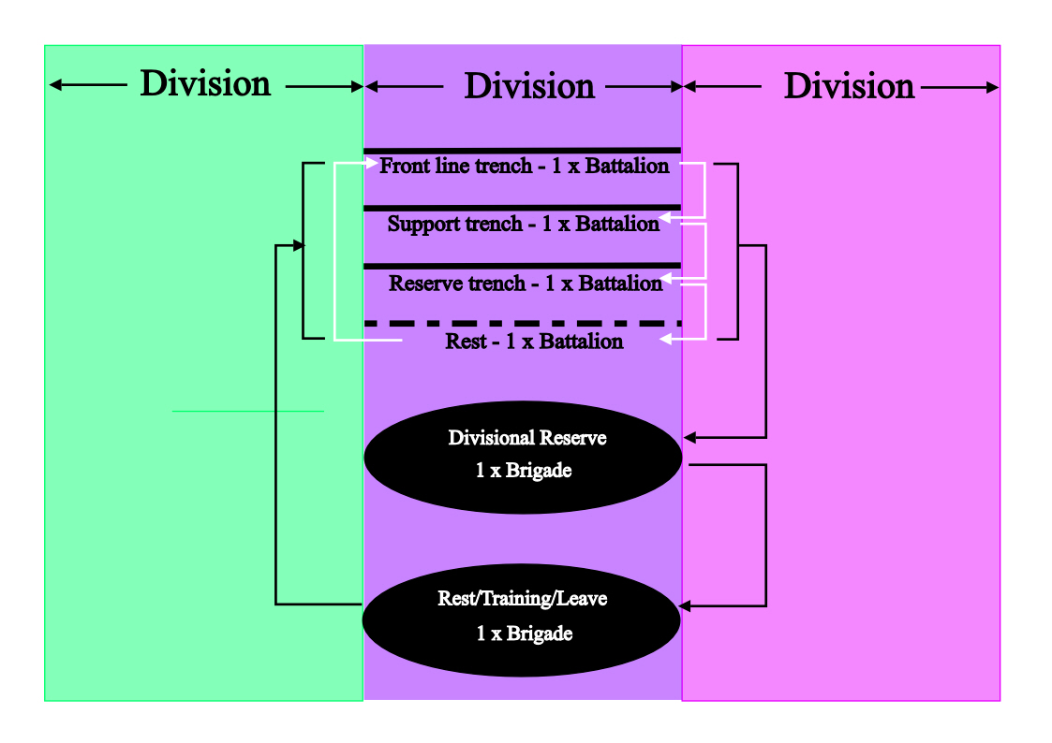
For a major attack, all four Battalions of a Brigade would be forward and advance from the front line trenches. The map at Appendix 14 shows the trench lines on 4 June - the lines which had been achieved by the advance of 28 May in which Tom was killed. These lines have been superimposed on a current day map (Appendix 15). Tom must have been killed along the line of the 127th (Manchester Infantry) Brigade and somewhere in the area back from this line to a distance of 100-150 yards (the white "box" on the map). However, the objective of the advance of 28 May was to bring the Battalion line up to the Royal Naval Brigade line on the right. The 4 June attack saw the 1/7th Battalion on the extreme right of the 127th Brigade line with the Royal Naval Brigade to their immediate right. It therefore seems likely that the location of Tom's death is towards the right of the 127th Brigade line shown on Appendix 15.

Records, Medals and Memorials

National Archives:

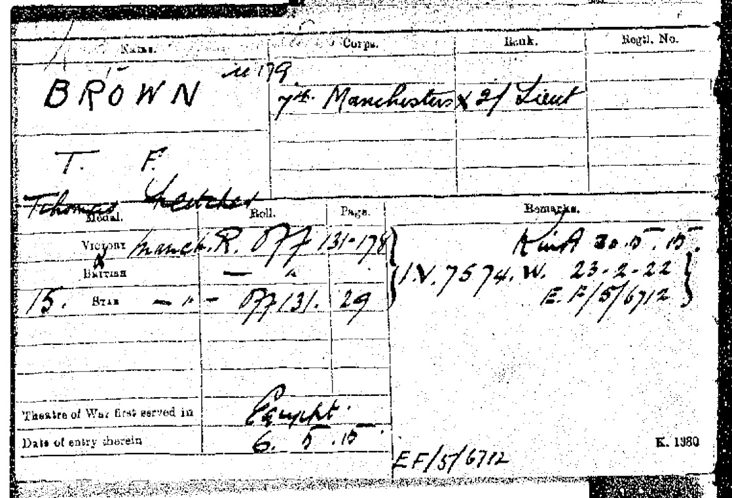

Commonwealth War Graves Commission:

BROWN, THOMAS FLETCHER | Second Lieutenant |  | 30/05/1915 | 20 | Manchester Regiment | United Kingdom | Sp. Mem. A. 110. | REDOUBT CEMETERY, HELLES

Extract from "The Manchesters":

"2nd Lieut T. F. BROWN - 29 May 1915.
Second-Lieutenant T. F. Brown was gazetted 2nd September, 1914, and proceeded with the Battalion to the Sudan. He was 20 years of age, and an Irishman. Lieutenant Brown was killed during an advance made by the Battalion on 28th May, 1915."

Extract from "To What End Did They Die?", by RW Walker, published by RW Walker Publishing, 1985:

"BROWN 2nd Lieutenant Thomas Fletcher
1/7th Bn. T.F. The Manchester Regiment

Parents: William Brown and Lizzie of Belfast. WG. Gall.2. Killed in action 30th May 1915 aged 20 years. Comm., Redoubt Cemetery."

Forces War Records:

First Name: | Thomas Fletcher
Initials: | T F
Surname: | Brown
DOB: | Circa 1895
Age: | 20
Nationality: | British
Date of Death: | 30/05/1915
Information: | Parents: William and Lizzie Brown, of 204, Shankhill Rd., Belfast.
Rank: | Second Lieutenant
Campaign Medals: | 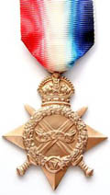  1914/15 Star  Thomas Fletcher Brown was awarded the 1914-15 star campaign medal of the British Empire for his service in World War One.  This Star is identical to the 1914 Star in every respect except that the centre scroll bears the dates “1914- 15” and the two small scrolls bearing “Aug” and “Nov” are omitted.  As Thomas Fletcher Brown was a recipient of this medal he also received the British War Medal and Victory Medal, as it was not awarded singularly. These three medals were sometimes irreverently referred to as Pip, Squeak and Wilfred. With Pip representing either this medal or the 1914 Star, only one of which could be awarded to a soldier, Squeak represented the British War Medal and Wilfred represented the Victory Medal.

www.instgreatwar.com/page5.htm:
"Second Lieutenant Thomas Fletcher Brown- died 30/5/1915
7th Manchester Regiment
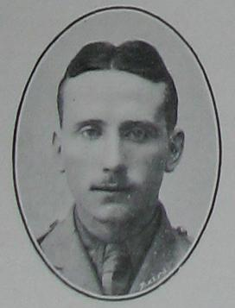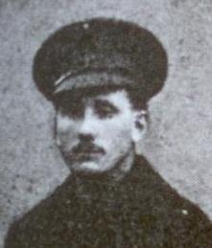
Thomas was the son of William and Lizzie Brown of 204 Shankill Road, Belfast. He was appointed to a commission with the 7th Battalion, Manchester Regiment on 2nd September 1914 and embarked for Egypt 9 days later.
27 days after leaving Egypt for the Dardanelles, Thomas was killed in action on 30th May 1915, at the age of 20, and is buried in the Redoubt Cemetery (ref. Sp Mem A 110), Helles, Turkey."
Photograph of Tom's Medals:
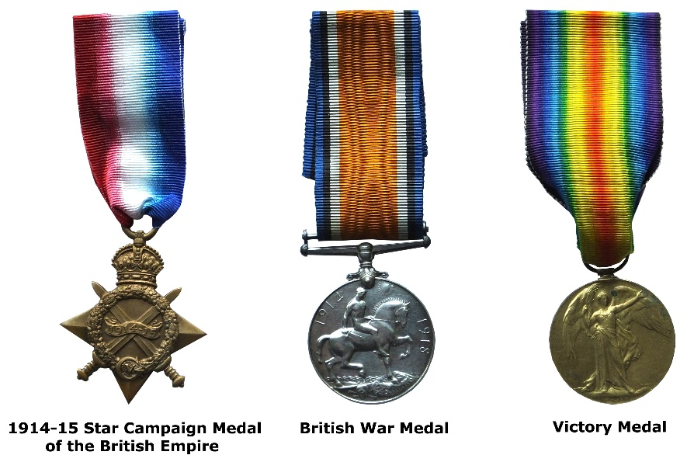

The Princess Mary 1914 Christmas Gift:

In November 1914, an advertisement was placed in the national press inviting monetary contributions to a 'Sailors & Soldiers Christmas Fund' which had been created by Princess Mary, the seventeen year old daughter of King George V and Queen Mary. The purpose was to provide everyone wearing the King's uniform and serving overseas on Christmas Day 1914 with a 'gift from the nation'.

The response was truly overwhelming, and it was decided to spend the money on an embossed brass box, based on a design by Messrs Adshead and Ramsey. The contents varied considerably; Officers and men on active service afloat or at the front received a box containing a combination of pipe, lighter, 1 oz of tobacco and twenty cigarettes in distinctive yellow monogrammed wrappers. Non-smokers and boys received a bullet pencil and a packet of sweets instead. Indian troops often got sweets and spices, and nurses were treated to chocolate. Many of these items were despatched separately from the tins themselves, as once the standard issue of tobacco and cigarettes was placed in the tin there was little room for much else apart from the greeting card.

Photograph of Tom's Christmas Gift:

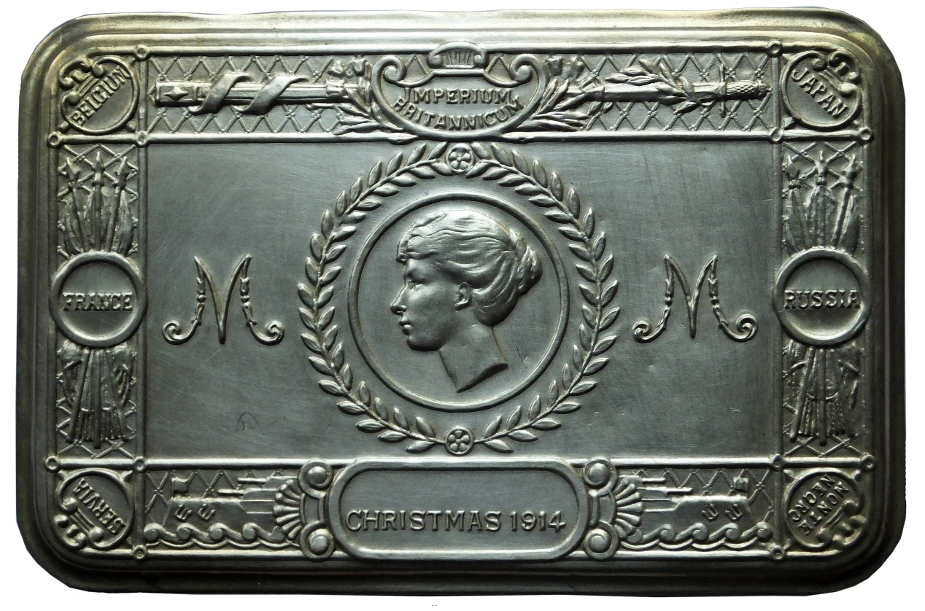

Photograph of Tom's Memorial Plaque (Medallion):
The Memorial Plaque was issued after the First World War to the next-of-kin of all British and Empire service personnel who were killed as a result of the war.
The plaques (more strictly described as plaquettes) were made of bronze, and hence popularly known as the "Dead Man’s Penny", because of the similarity in appearance to the somewhat smaller penny coin. 1,355,000 plaques were issued, which used a total of 450 tonnes of bronze, and continued to be issued into the 1930s to commemorate people who died as a consequence of the war.
Tom's Memorial Plaque:
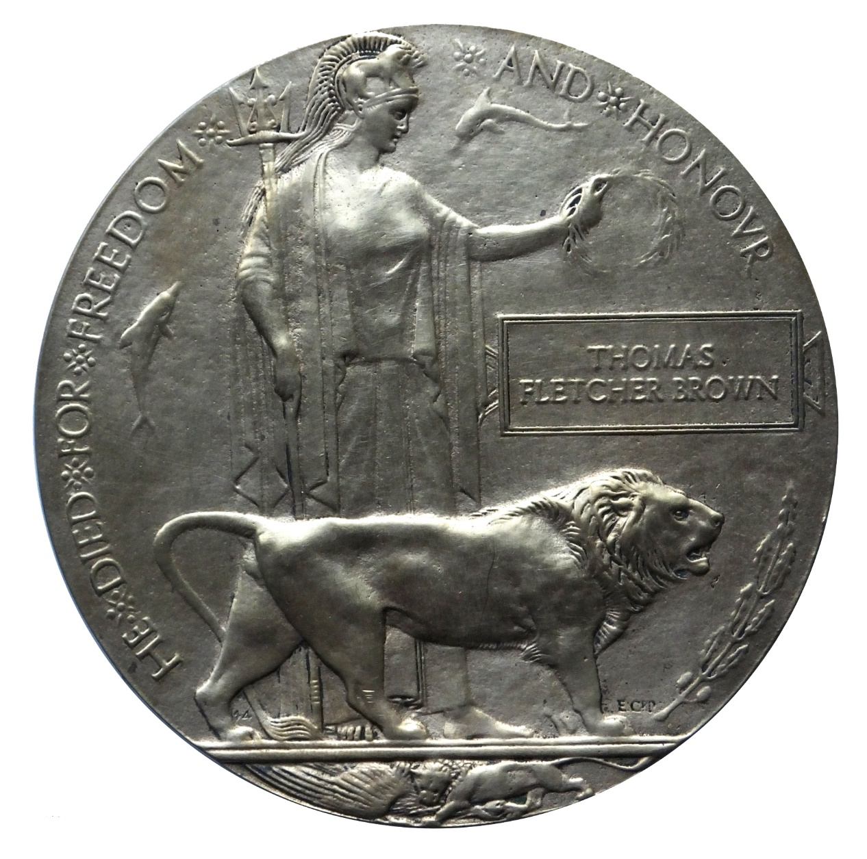

Photograph of Tom's Cap Badge:
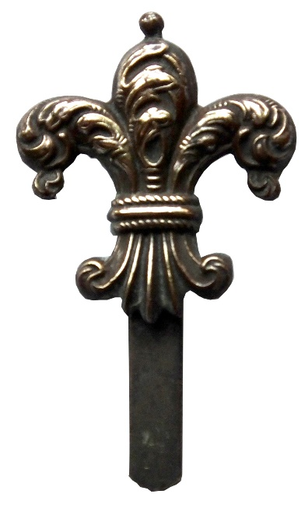

Memorial to the 1/7th (Territorial Force) Battalion, The Manchester Regiment, located in Whitworth Park, Oxford Road, Manchester:

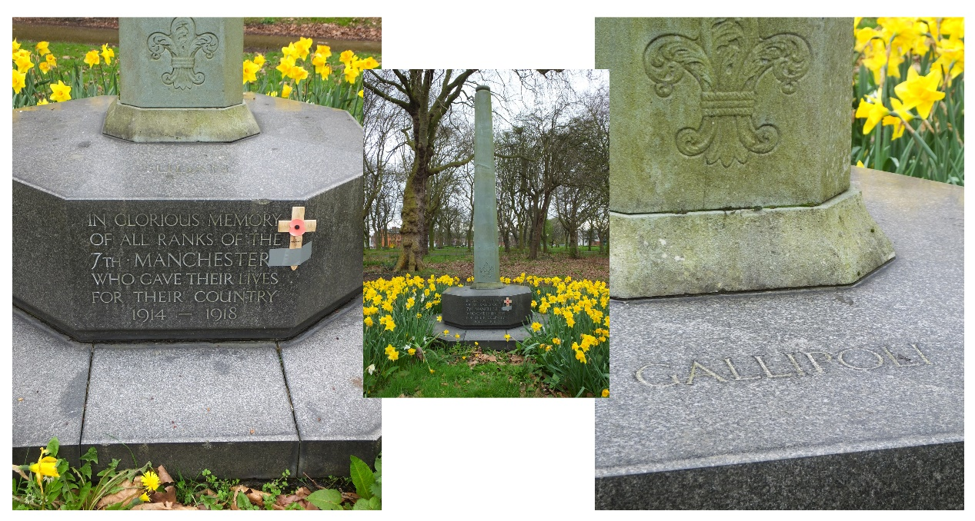

Memorial to the Members of the University and the Officer Training Corps who died in the Great War, located at the front of Queen's University, Belfast:

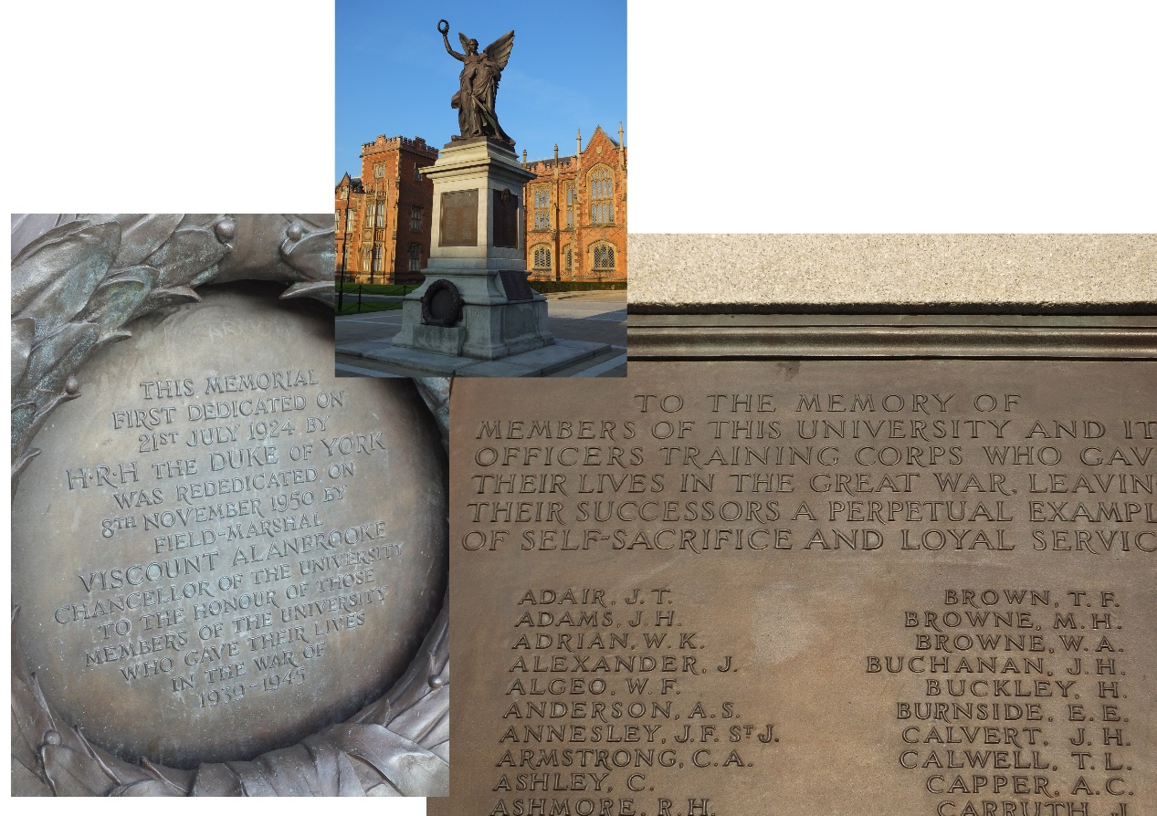

Redoubt Cemetery

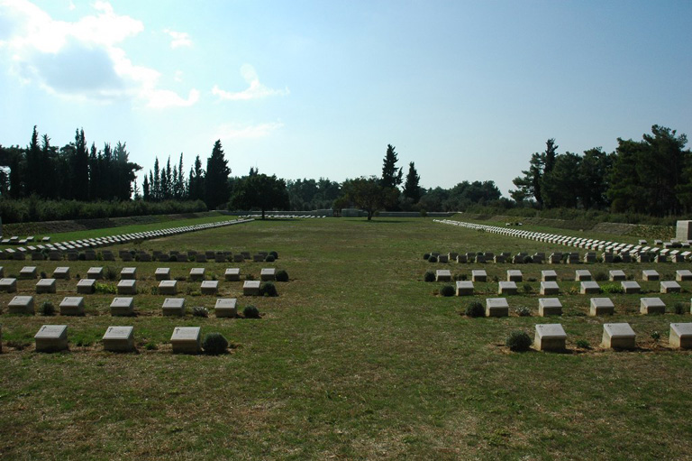

Redoubt Cemetery takes its name from the chain of forts made by the Turks across the southern end of the peninsula in the fighting for Krithia and the Redoubt Line on which the advance halted in May. Its location can be seen on the map at Appendix 15, and a plan of the cemetery is at Appendix 16.
The cemetery was begun by the 2nd Australian Infantry Brigade in May 1915 and continued in use until the evacuation. It was greatly increased after the Armistice when the battlefields were cleared and graves were brought in from the following smaller cemeteries:-
Krithia Nullah Nos. 1 and 2, West Krithia Nullah, Brown House, White House and Clapham Junction.
There are now 2,027 servicemen of the First World War buried or commemorated in this cemetery. 1,393 of the burials are unidentified but special memorials commemorate 349 casualties known or believed to be buried among them.

Tom is recorded as being buried in the Redoubt Cemetery Special Mememorial A 110. It is assumed that Tom is one of 349 commemorated as being buried there.

Postscript

The following extracts are presented to show that there was some contact between Jack's family and Tom's parents after Tom's death, but also to give a little insight to the life and routines of a 2/Lieutenant, and hence Tom, in the front line.

All extracts from "I Remain, Your Son Jack".

On 1 August 1915 Private Jack Morten wrote to his mother:

"I'm awfully glad you wrote to Lt Brown's people. Do you know, in our Company we have only one Officer left who was at Khartoum with us & he is Lt Whitely."

On 1 September Jack wrote to his Mother and Father to tell them that he had been Commissioned as a 2/Lieutenant in the 1/7th Battalion:

"2nd Lieutenant Morten
1st/7th Manchester Battalion
Thursday Sept 1st 1915

My dear Mother and Father,
I hope your eyes will not drop out when you see my new address, as it would be a shame if you were not able to read all my delightful news, but it's really true....... Yesterday I was called out of the firing line to appear before the Colonel whereupon he informed & congratulated me upon my good luck. Now came the problem of rigging me out, which was rather a difficult one as there are no Officer's kits in the Peninsular. Then of course whilst we are out here all that I require are decent clothes, whether Officer's or Private's, so I went down to the Stores & got a pair of riding breeches & an ordinary tunic. Of course I have got the stars on the shoulders as a distinguishing feature.
This being fixed up, I had to look out for a servant. Here again I dropped in very lucky by getting hold of a man who has about thirty years service in the Army, so he has plenty of experience. He came out with the last batch. He was one of the cooks in the second 7th and I might say that he has already proved to me his excellent capabilities at cooking"

It is interesting that the appointment of a "servant" (or as referred to elsewhere as "my man") was second on the priority list for a newly Commissioned Officer after insignia of rank.

On 13 September Jack wrote:

"Lieutenant Morten Monday Sept 13 1915

Dear Pat,
Just a few lines to say that I'm in the pink & find the change still agreeing with me. We are in the firing line, having come up this morning after spending three days in the Duplicate firing line.
Perhaps it would interest you to know the routines we go through daily when in the line. At day-break which is about 4.30 am, the Company stand to, that means to say that all the men waken up & stand against the parapet with bayonets fixed. We also go through the same procedure at sunset which at this time of year is about 6.30 pm. I might mention that the duration of this stand-to is only for an hour & it is in case the enemy take it into their heads to attack, in which case they would find us waiting to welcome them, & much to their sorrow they have had one or two of our welcomes so I don't think they will bother us again. But in case they do feel like paying us a visit we are always ready.
I must give the Turks their due, they appear to be most devoted to their religion, & every daybreak or sunset they say or rather wail their prayers. Whether their belief is conscientious or whether it is a belief frightened into them by some priest or other I cannot say, however, in any case it is a jolly sight better than having no religion at all & I wouldn't object if they would do it quietly, but they have a kind of chant & our trenches are so near that every day at the stand-to we can hear them quite distinctly & it is most weird.
Of course I do not now Stand-to but I have to patrol up & down the line with the other three Officers to see that the men do not sit down. The Stand-to being over Captain Smedley sends word along for the three of us & we have a cup of tea or cocoa in his dug-out & half an hour's chat afterwards retiring to our dug-outs, usually for a little more sleep or if we are bursting with energy we read & write. Myself & the other 2nd Lieutenant usually go for the former recreation; I always have my best sleep from 6.30 to 8.30 or 9 am & as a rule don't waken up until my man puts the bacon & eggs (eggs are not an Army issue) under my nose, then my latent energy springs up & I do full justice to it. Breakfast over, I have a good swill, then at 10 o'clock or 10.30 am I inspect the rifles & gas helmets of my men.
I don't have much for lunch as it is so hot, but a favourite lunchtime dish of mine is to have one suet dumpling with Golden Syrup over it & 2 cups of tea (my man is a dab-hand at making dumplings). In the afternoon I do all my writing & have dinner about 6 pm which consists of steak & eggs or else a stew washed down with 2 cups of tea. My menu is not a very varied one but I always enjoy my meal. Then of course at times we can procure tinned fish & fruit from the canteen, but the demand is so great that usually by the time my man gets down from the trenches they have nothing left but eggs & milk. Then after dinner comes the evening Stand-to after which I get down for a night's sleep except for any patrol, which is for two hours a night. The four of us take different watches in turn. I prefer the first watch from 8 till 10 so that I know when I have finished
for the night."

On 20 September 1915 Jack wrote:

"My Dear Mother
By the last mail which arrived the day before yesterday I received 4 letters, one from yourself & also father's dated Sept 1st and a letter of congratulation from Mr Brown of Belfast. I suppose he saw it in the Times newspaper"

On 6 February 1916 Jack wrote:

"PS. The other day I had a letter from Mr Brown, Belfast in which he asked me when writing home, to give you his & Mrs Brown's kind regards."

Visit to Gallipoli - 12 May 2014
The following photographs were taken on a visit to Gallipoli in May 2014. They all relate to areas discussed in the previous chapters and therefore require only a caption.

Arrival:

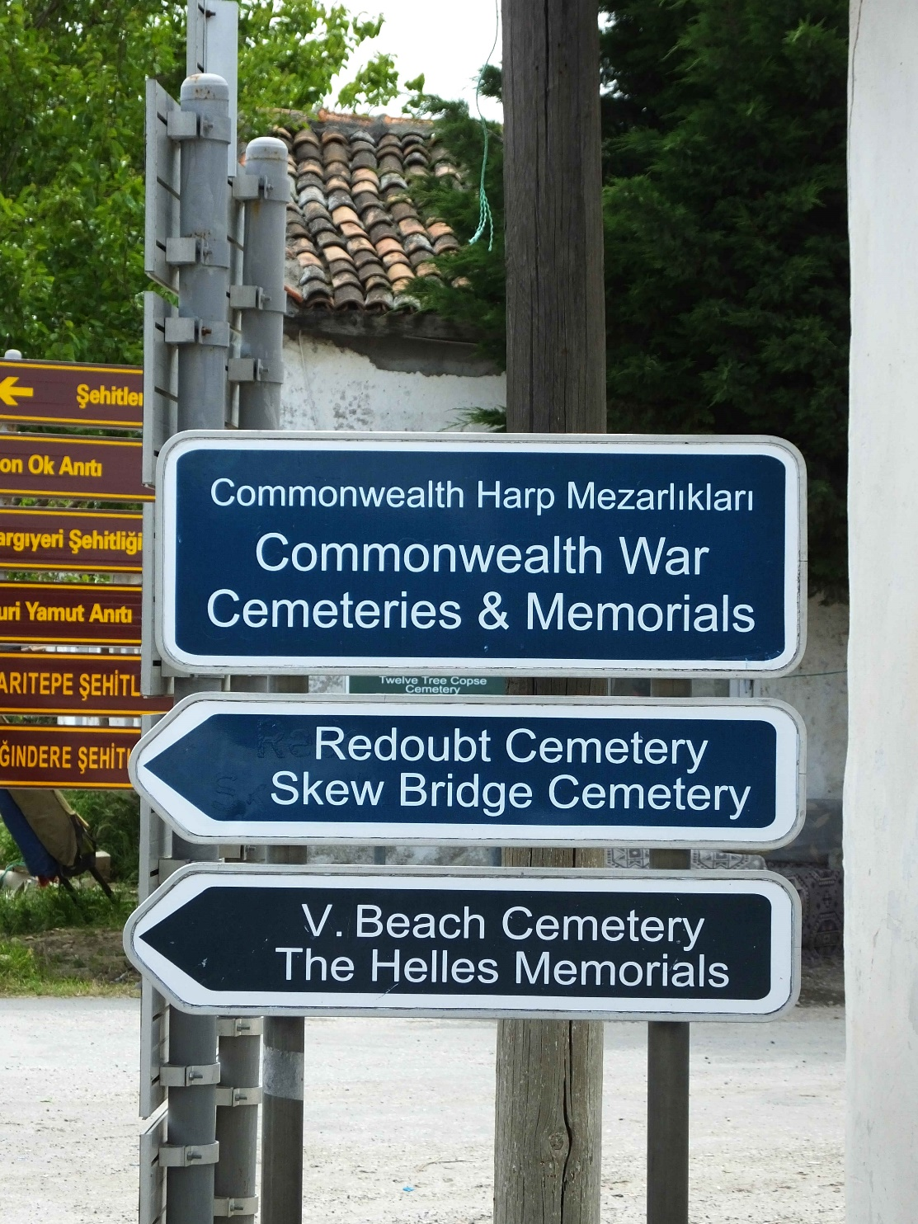

'V' Beach, Cape Helles:
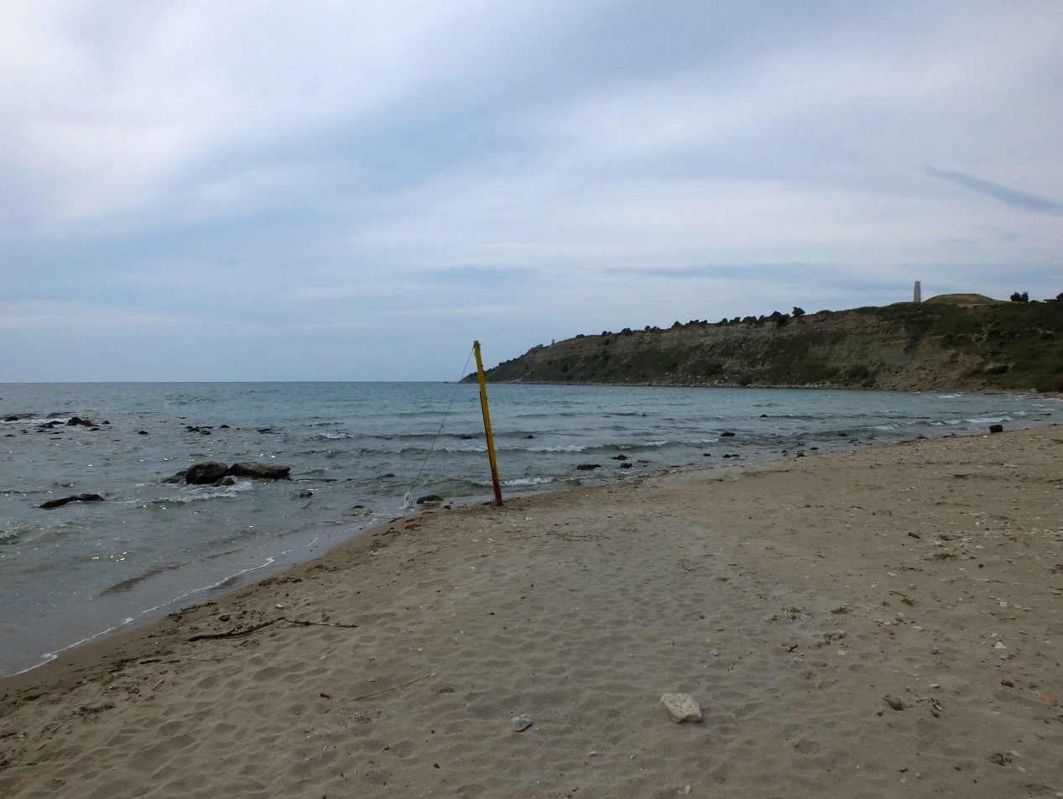
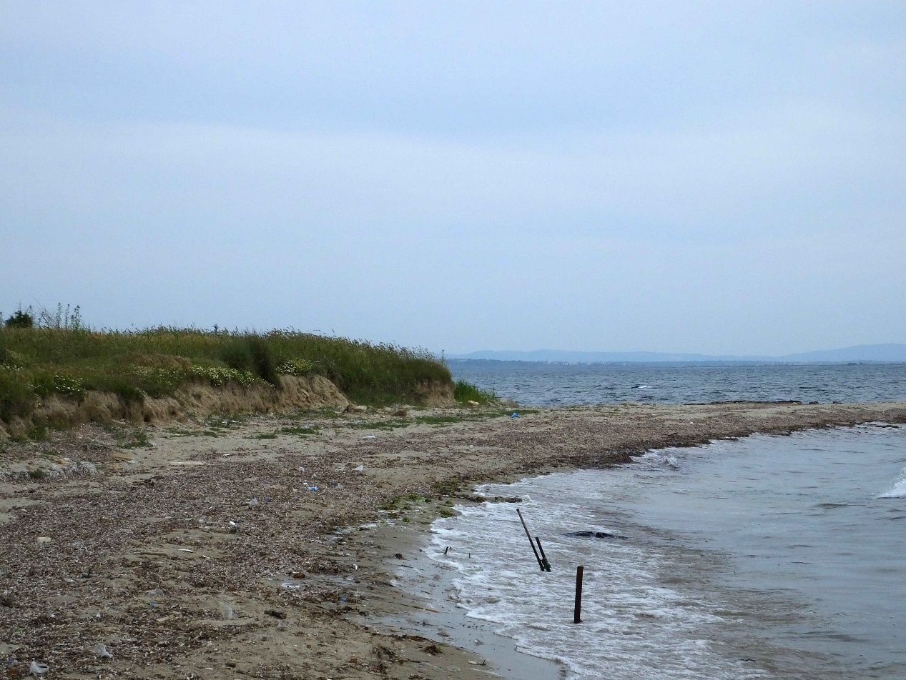
'V' Beach Cemetery:
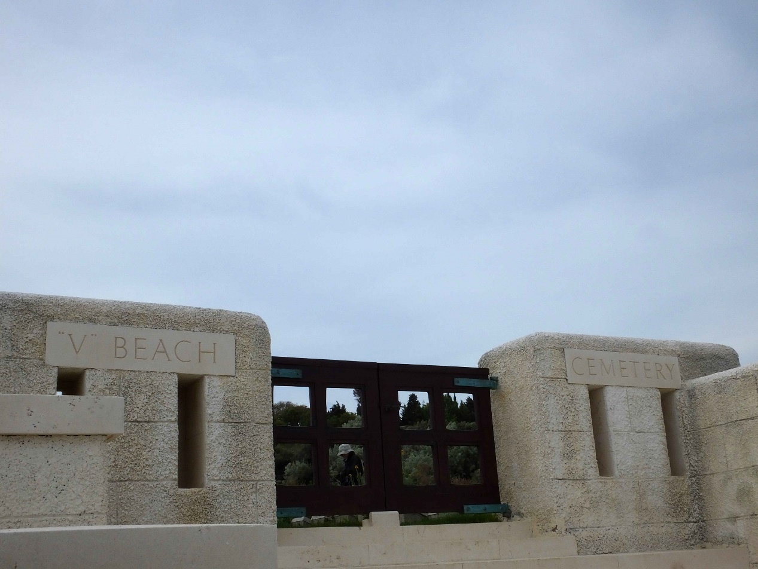
Cape Helles Allied Memorial:
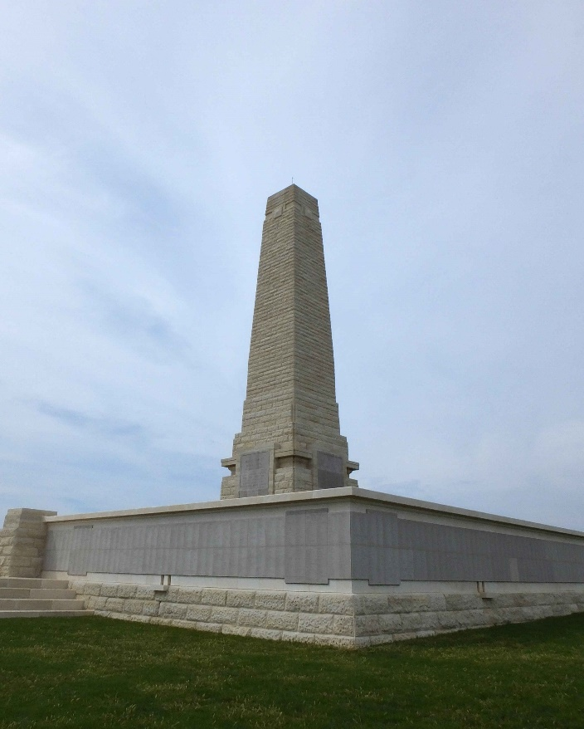
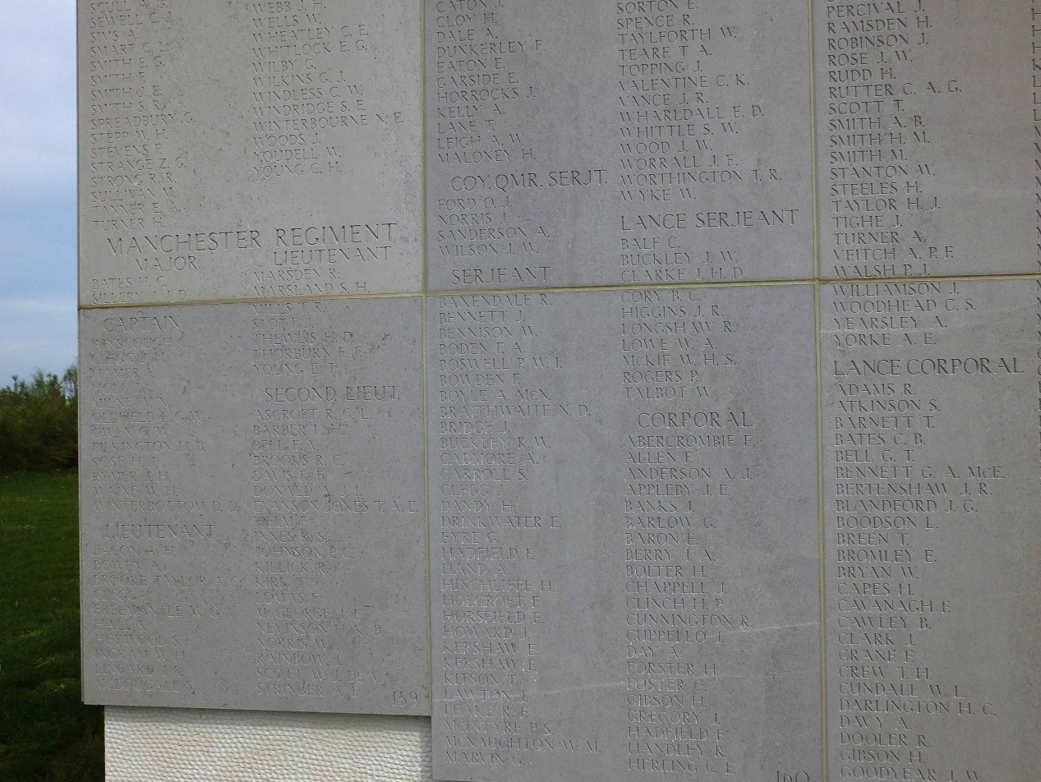

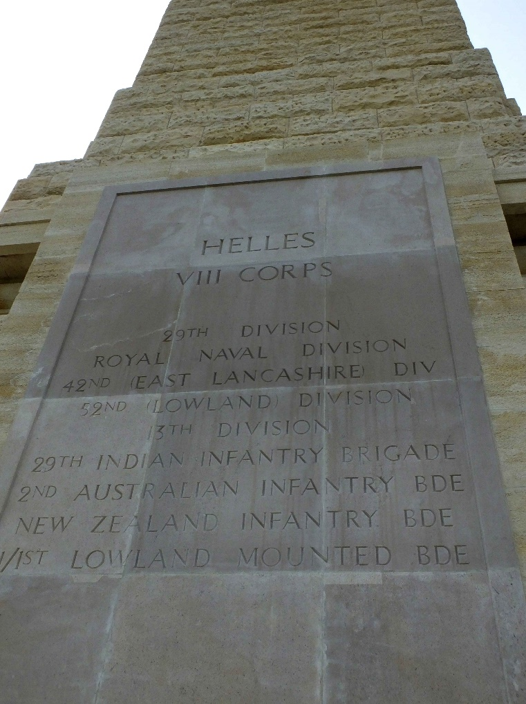
Redoubt Cemetery:
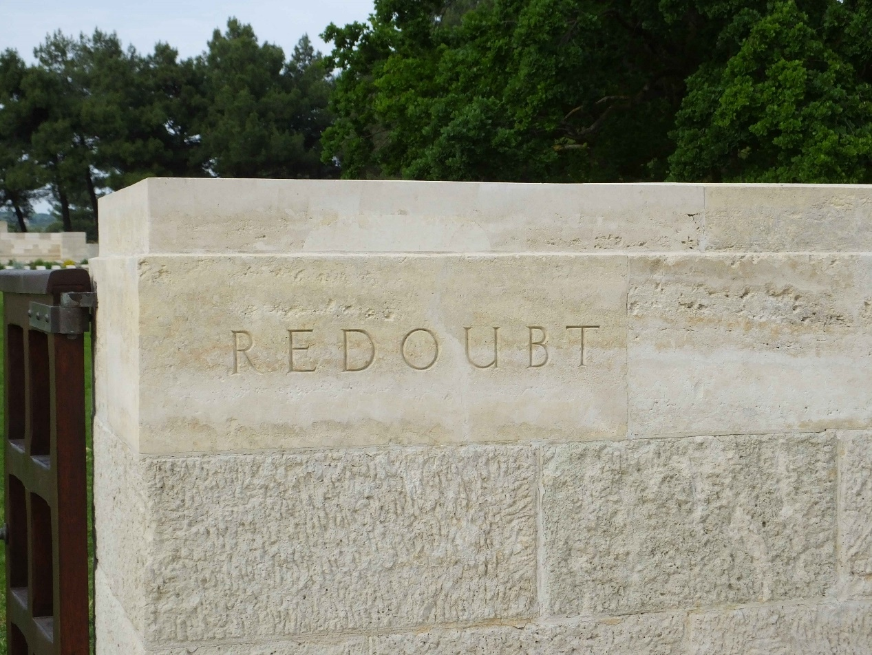

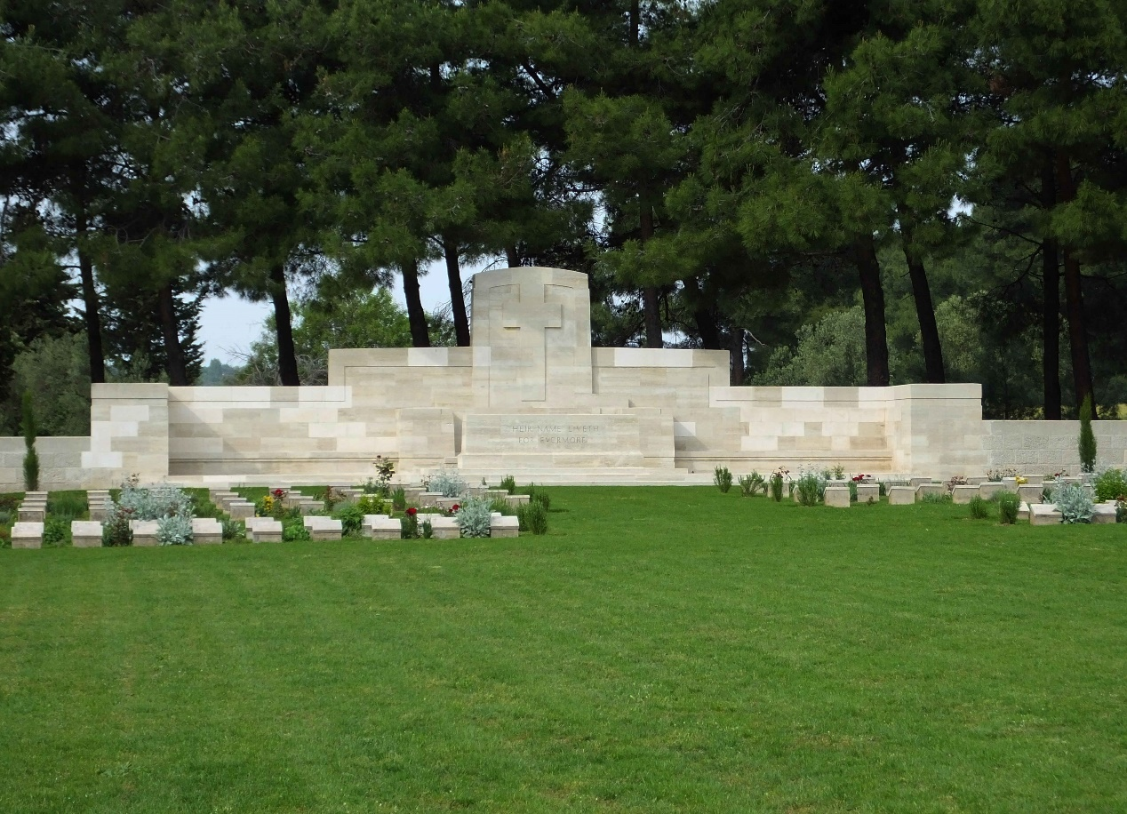
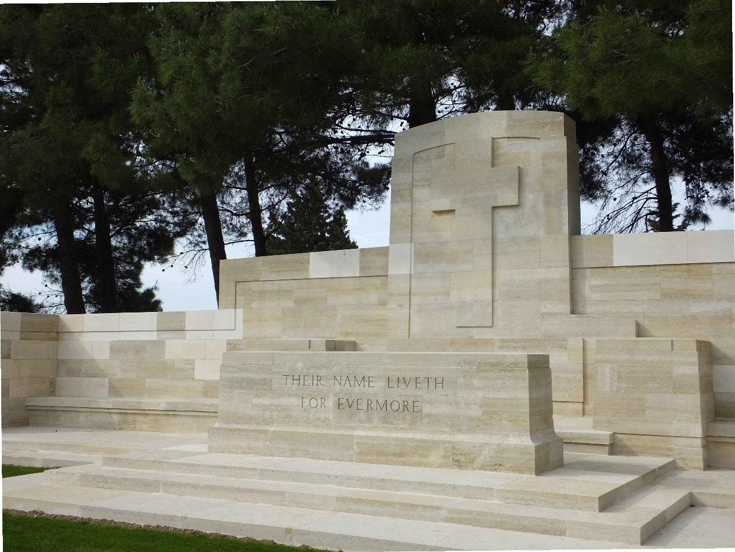

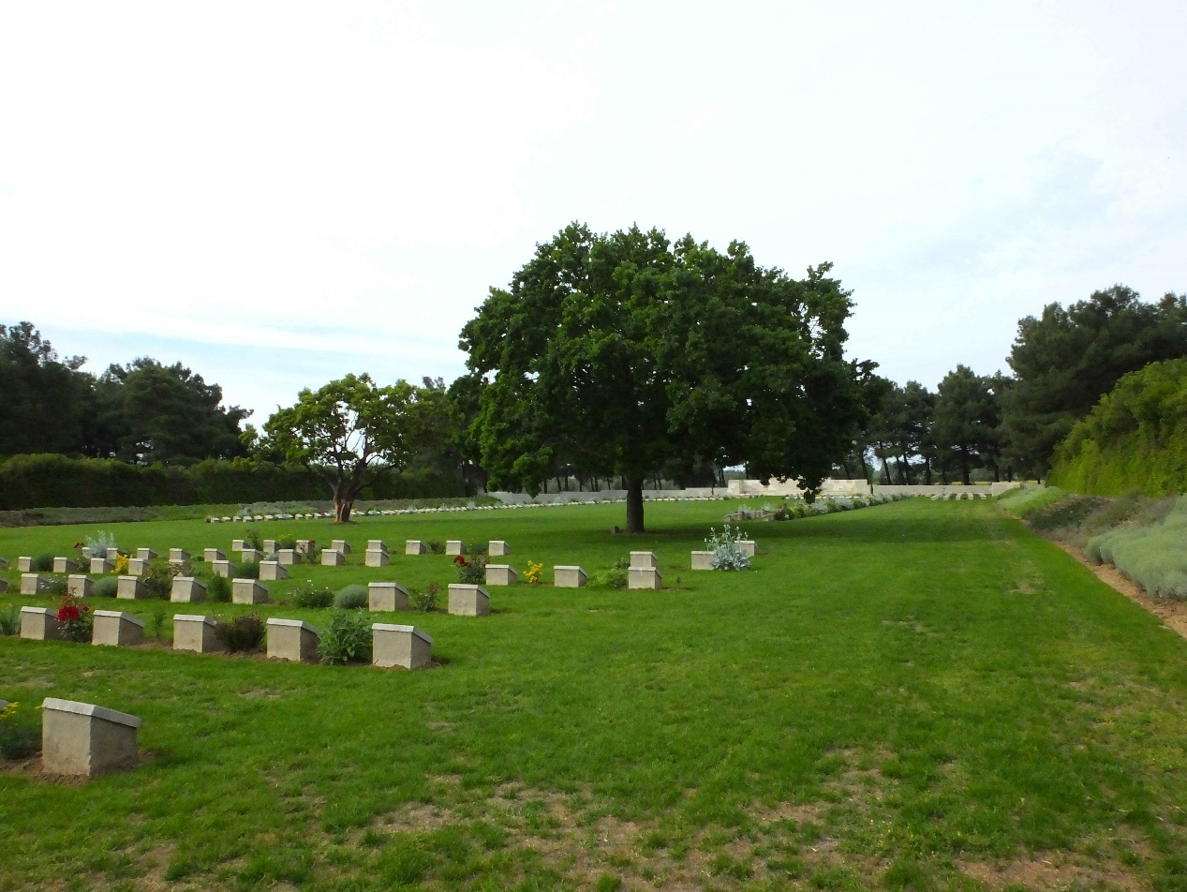
Tom's Memorial:

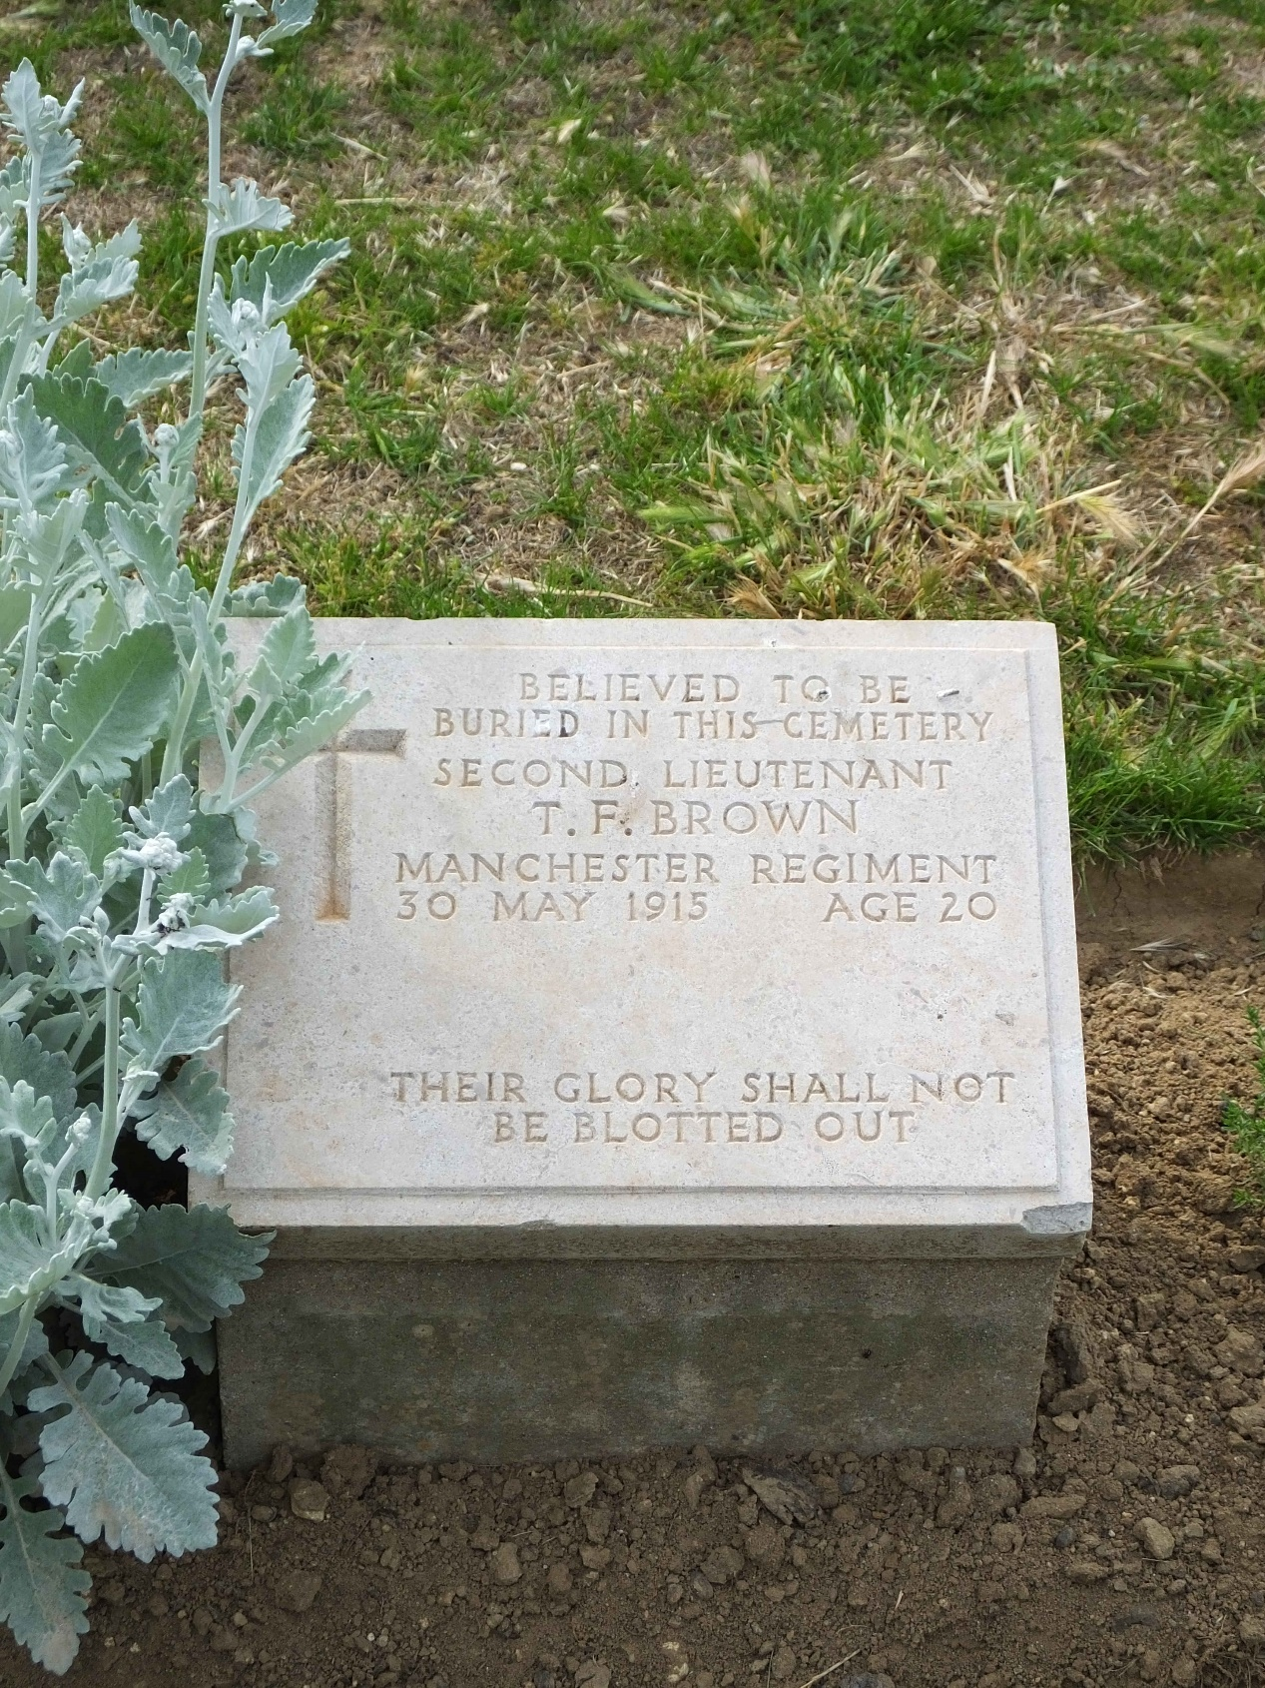

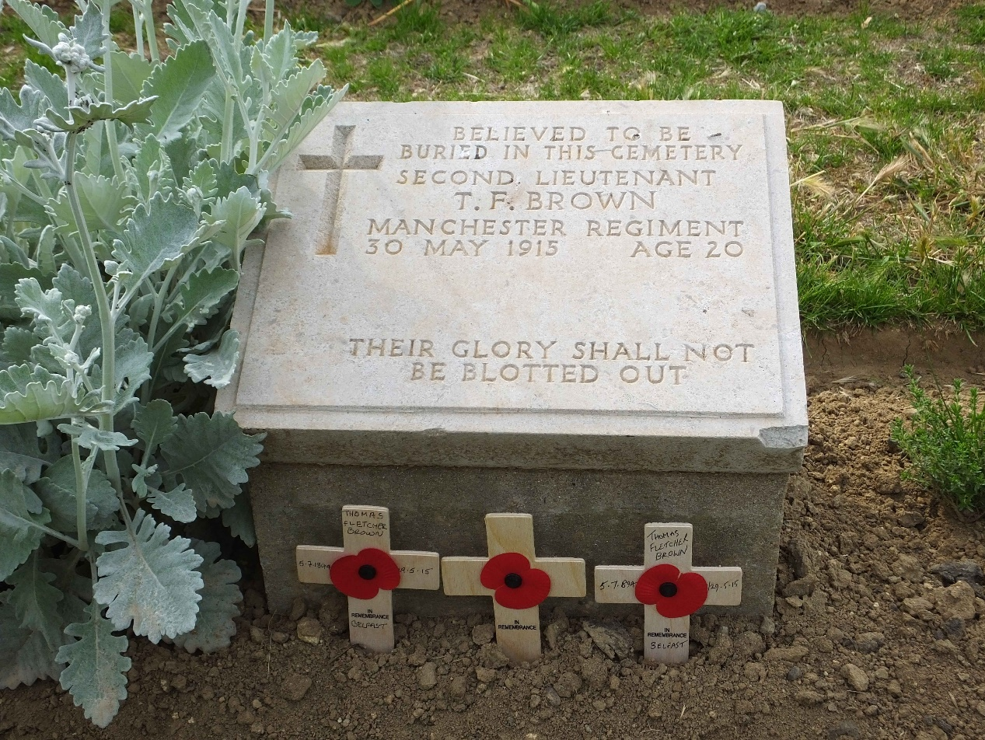
Area where Tom is possibly buried:
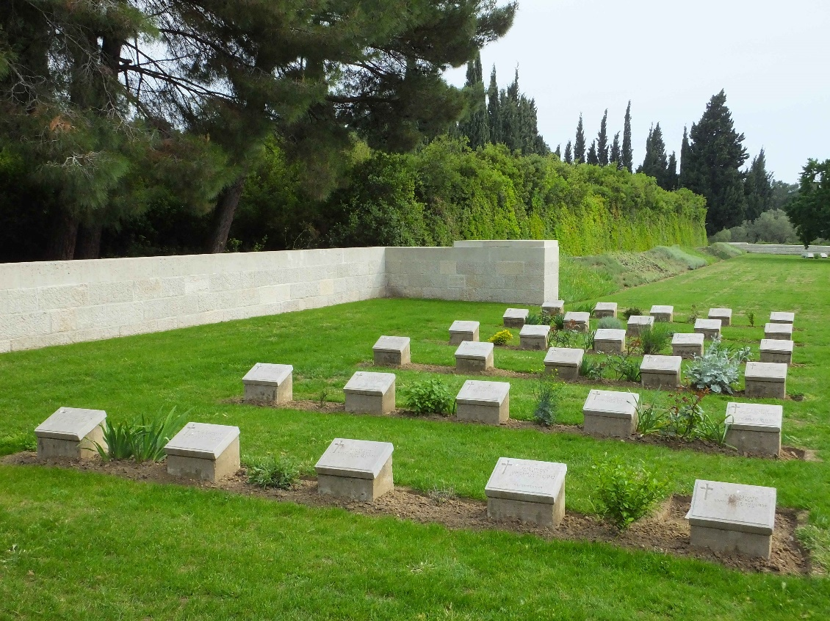
Area where Tom was possibly killed:

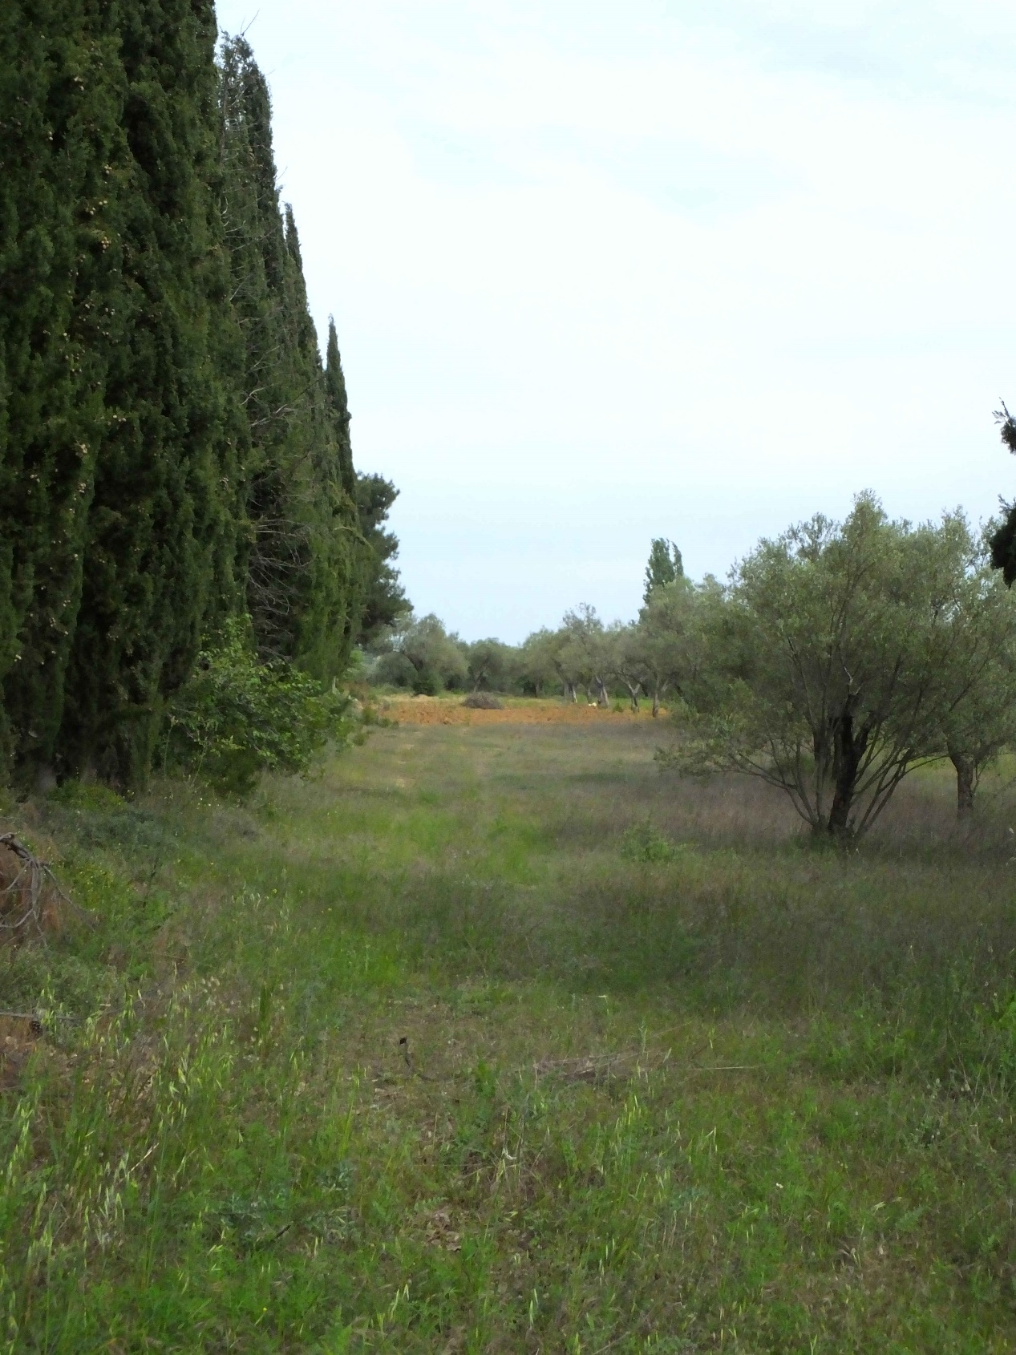

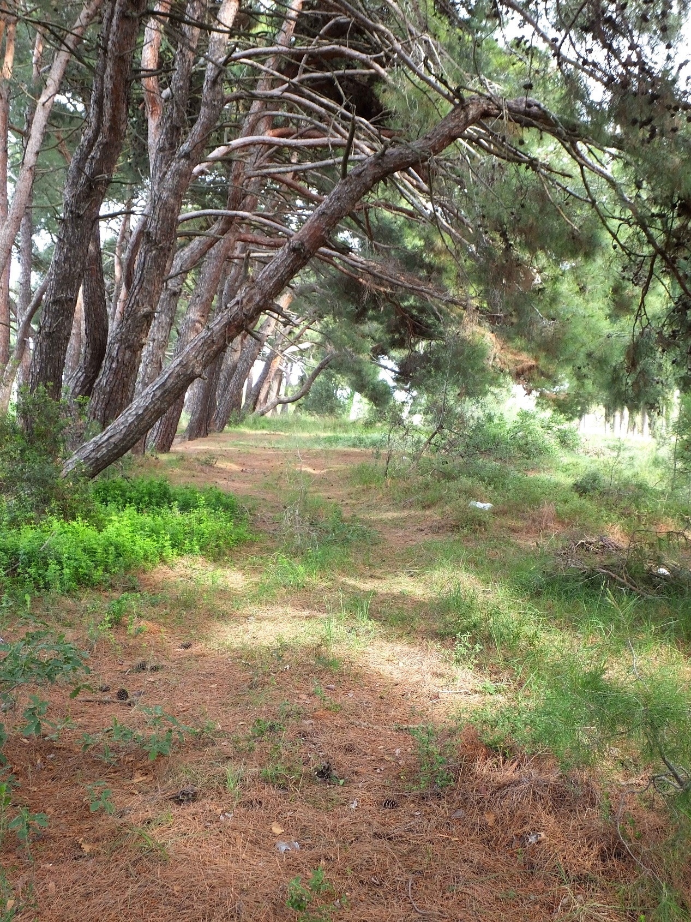

Tom's fellow Officers killed in the same action:
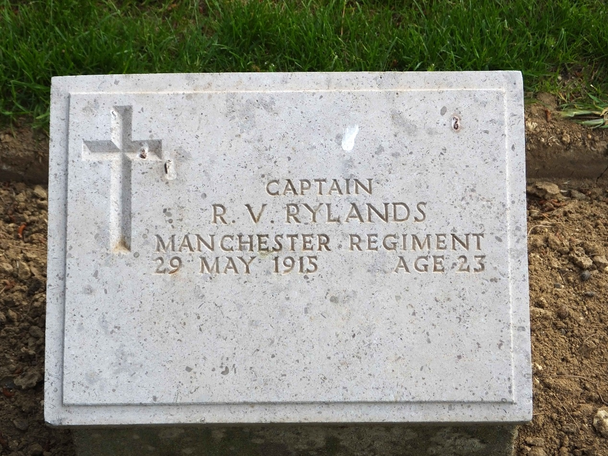
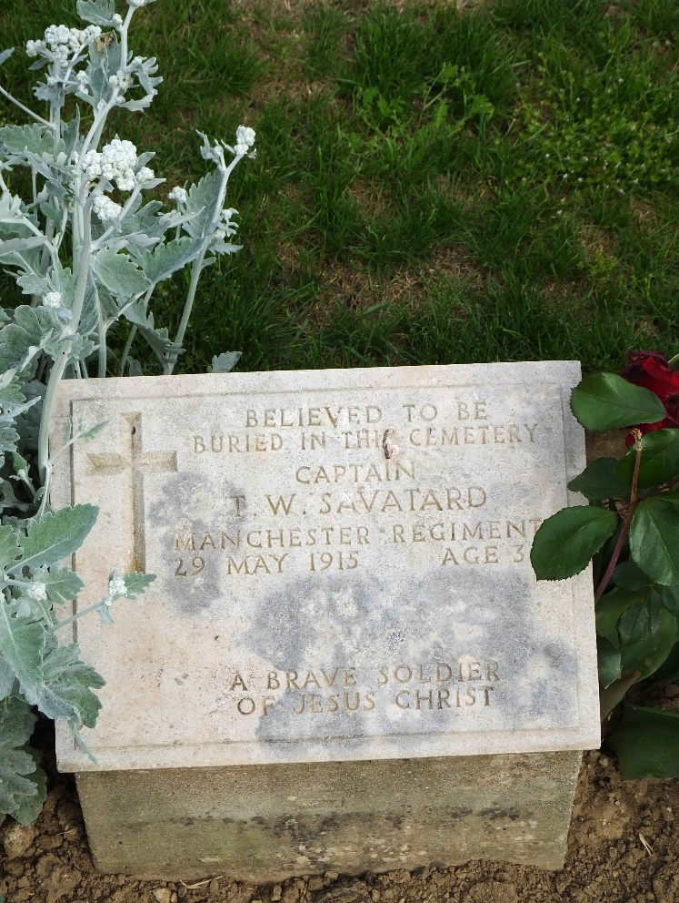

Appendix 3
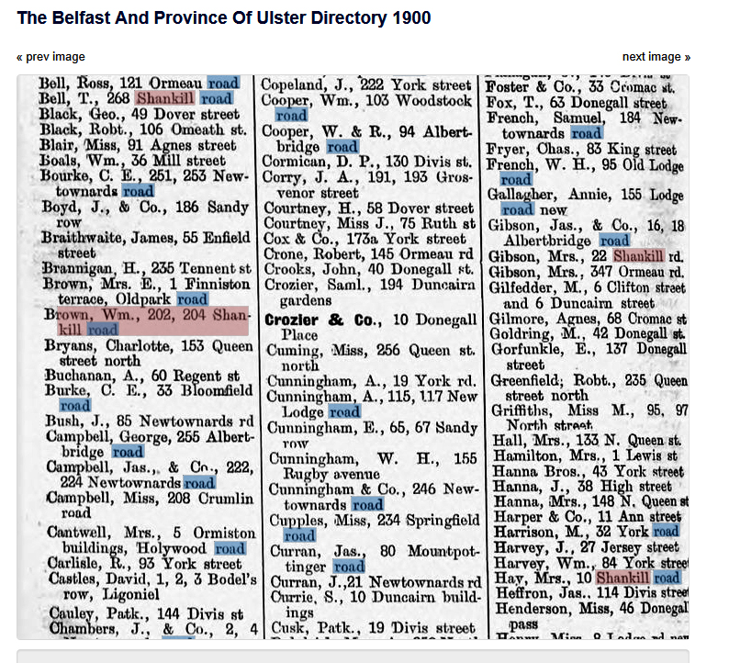

Appendix 4

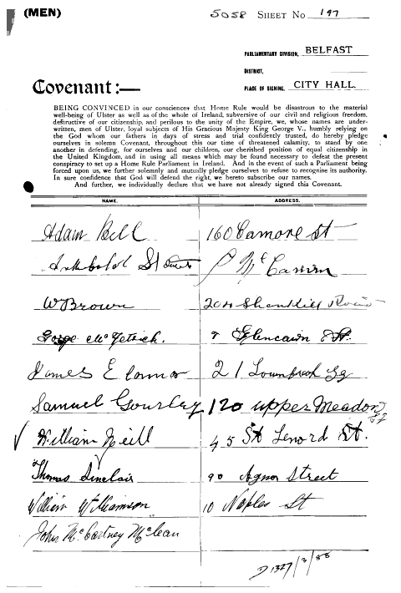

Appendix 5

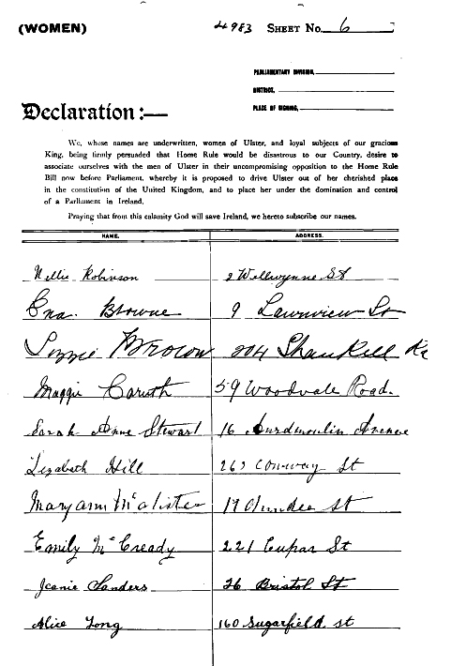

Appendix 6

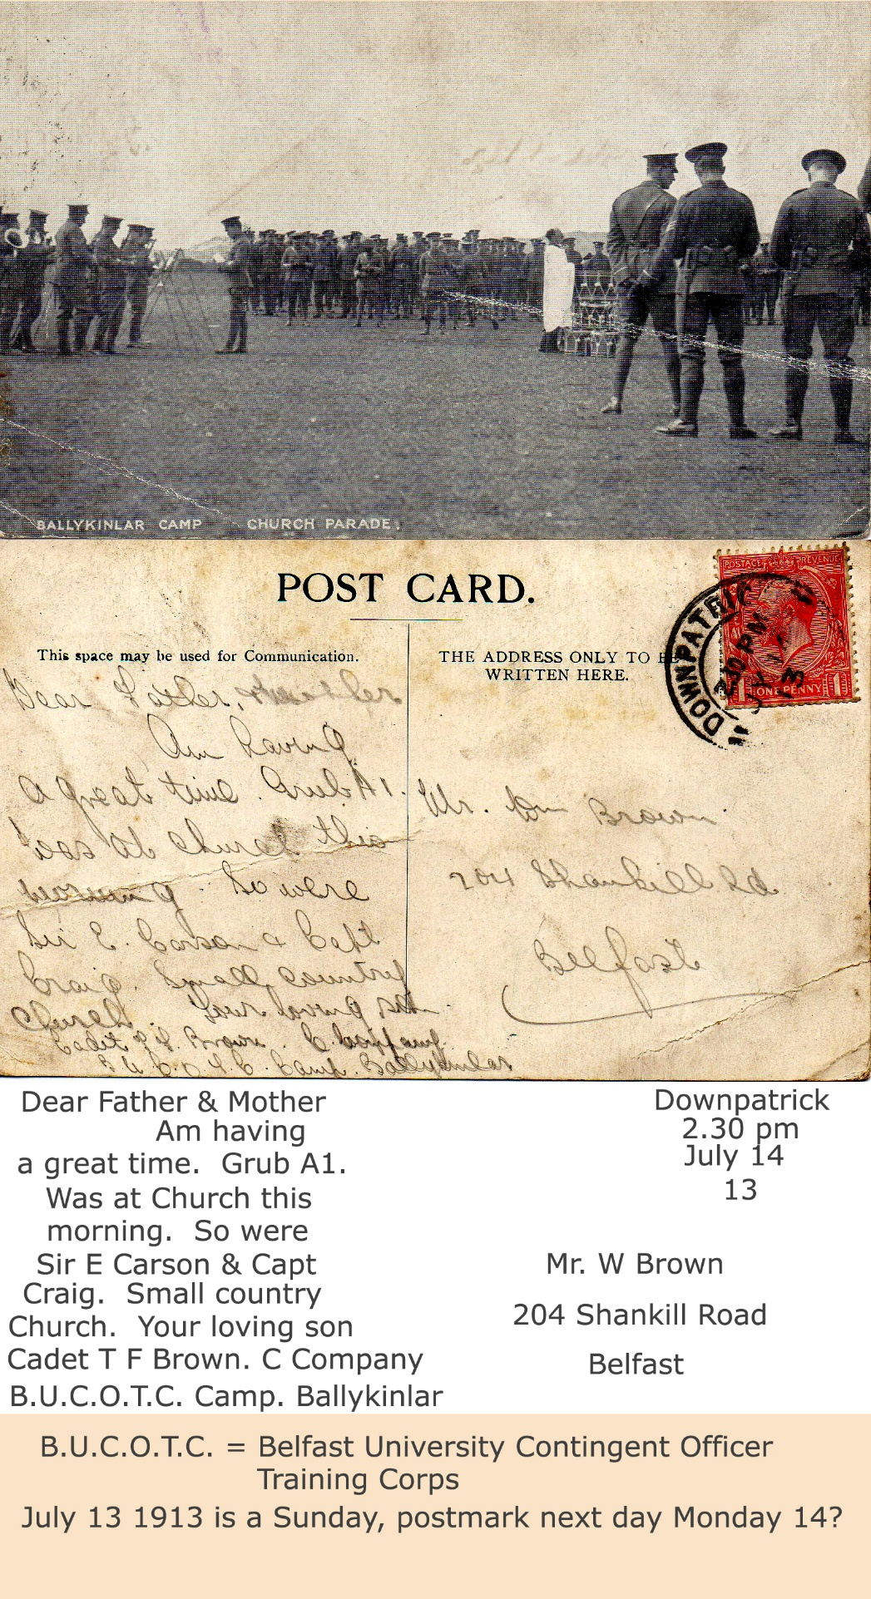

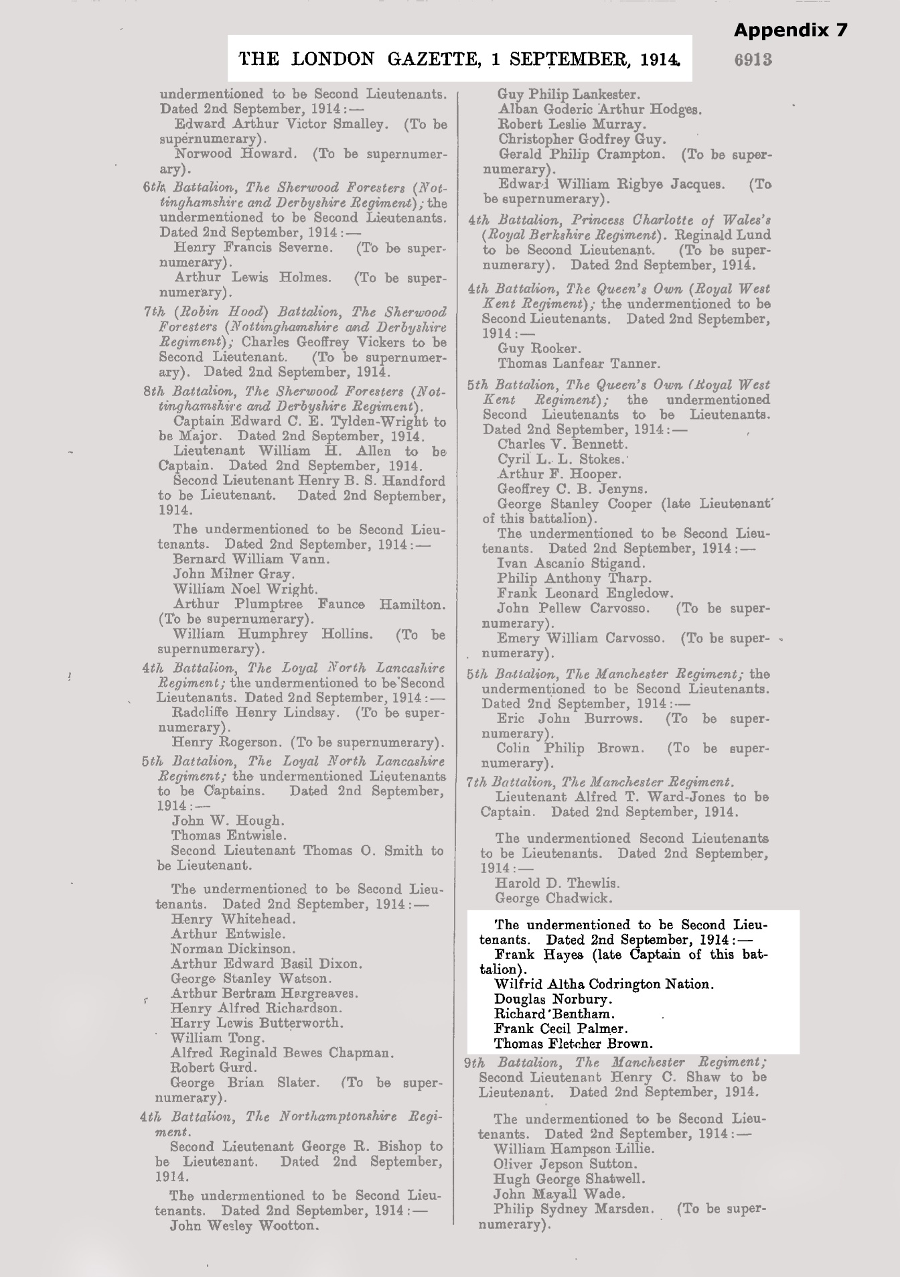

Appendix 10

HMHS GRANTULLY CASTLE
HMHS GRANTULLY CASTLE was built in 1910 by Barclay, Curle & Co. at Glasgow with a tonnage of 7612 gross tonnes, a length of 450ft 7in, a beam of 54ft 4in and a service speed of 13 knots. Together with her sister, the Garth Castle, she was one of the last pair ordered under the personal supervision of Sir Donald Currie who died on 23rd April 1909 at the age of 83. One of five ships built for the Intermediate trade she was given a 'G' name to replace the ex-Union 'G' class but the class was never as popular as the 'D' class ships. In January 1915 she was being used as a troopship and while at Mudros during the Gallipoli campaign, in company with the Alnwick Castle, and Balmoral Castle, was held for five weeks from 18th March when the troops, because of mines, were unable to force the Dardanelles straits until 23rd April when they eventually landed to oppose a re-inforced Turkish army. She left the Dardanelles on 1st May 1915 for Malta where she was commissioned as a hospital ship with 552 beds. She reverted to Union-Castle on 11th March 1919 and served for a further 20 years before being broken up in 1939.
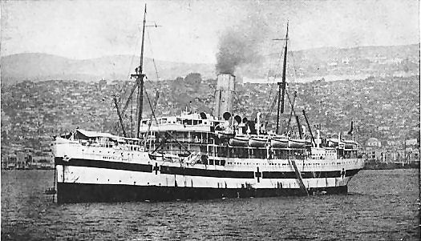

Appendix 11

HMS Minerva

HMS Minerva was an Eclipse class second class cruiser that served in the Red Sea, at Gallipoli and on the East Africa station during the First World War. At the start of the First World War the Minerva was part of the 11th Cruiser Squadron, based in Ireland and patrolling the trade routes to the west. In mid-August she was detached from that squadron, and sent south to join Admiral de Robeck’s 9th Cruiser Squadron, to guard against the German raider Kaiser Wilhelm der Grosse. The squadron also had the job of catching German and Austrian merchant ships that were still at sea. The difficulty of this job is demonstrated by the case of the Austrian Lloyd Line ship Bathori. She was travelling from Amsterdam to Vigo, with a British pass. The Minerva seized and scuttled her, unaware of this pass. The crew were then repatriated and the British government agreed to consider paying compensation to her owners after the war.
In September 1914 the Minerva escorted a troop convoy containing the East Lancashire Territorial Division, going to Egypt, and two Territorial Brigades, going to Gibraltar and Malta, to free up regulars for the western front. The Minerva was then detached from de Robeck’s command to go to the East Indies.
She reached the Suez Canal on 30 October with the convoy. She was then sent to Aqaba, at the head of the Red Sea, to attack any Turkish troops using the coast road. On 29 December she bombarded an infantry working party close to the shore, but otherwise it was a quiet area. Early in 1915 she returned to the Suez Canal. During the Turkish attack on the canal, her station was at the southern end of the Little Bitter Lake.
By March the Minerva was attached to the fleet off the Dardanelles. In April she was used to blockade Smyrna, while the army was being moved from Egypt to the Dardanelles, in preparation for the Gallipoli campaign. The only attack on the troop ships came on 16 April, when the Turkish torpedo boat Demir Hissar attempted to torpedo one troop ship. The Minerva was taking on coal, but was able to get to sea in time to help trap the Demir Hissar.
In April 1915 she was attached to the First Battle Squadron of the Gallipoli Fleet, helping to support the attack on the southern end of the peninsula. In August, during the Sulva landings, she was used to protect a feint attack made by 350 men at the head of the Gulf of Saros.
During 1916 she was sent to the China Station, but by the start of 1917 she was back in the Red Sea. In January 1917 she was sent to Socotra, at the entrance to the Red Sea, to protect against the German raider Wolf. She stayed off East Africa for the rest of the war – in November 1917, later in the raid of the Wolf, she was at Kilwa Kisiwani (Tanzania). She ended the war at the Cape of Good Hope.
Displacement (loaded) | 5,600t
Top Speed | 19.5kts
Armour – deck | 3in-1.5in
- gunshields | 3in
- engine hatch | 6in
- conning tower | 6in
Length | 373ft
Armaments as built | Five 6in quick firing guns  Six 4.7in quick firing guns  Six 3pdr quick firing guns  Two machine guns  Three 18in torpedo tubes
Armament after 1905 | Eleven 6in guns  Three 12pdr guns  Three 18in torpedo tubes
Crew complement | 450
Launched | 23 September 1895
Completed | 4 February 1897
Captains | P. H. Warleigh  Captain Jackson  Captain Raikes
Sold for break up | 1920

Appendix 12

S/S Ionian, Canadian Pacific Line

Burden | Built | Shipowner or operator | Dimensions
8,268 gross | 1901 at Belfast by Workman, Clark & Co. Ltd. | Canadian Pacific Line | 470ft x 57.5ft

Year | Remarks
1901 | Sept. 12, launched as the Ionian for Allan Line
1901 | Nov. 21, maiden voyage Liverpool - Halifax - St.John
1914 | Served as a troopship
1917 | Taken over by Canadian Pacific Line
1917 | Oct. 21, sunk off Milford Haven by mine, 7 lives lost

Details: 8,265 tons gross, 7,683 under deck and 5,337 net. Bridge deck 103 feet and forecastle 56 feet. Water ballast. She was constructed of steel, had twin screws and triple expansion engines, 2 x 3 cylinders of 23, 38 1/2 and 66 inches diameter each pair, stroke 48 inches, delivering 604 nominal horsepower. The engine was built by the same company as the hull. She had one funnel and four masts, 3 decks and was fitted with refrigerating machinery. She had accommodation for 131 passengers first class, 160 second class and 800 steerage passengers. Call sign: SWLK. Official registration #: 113989.
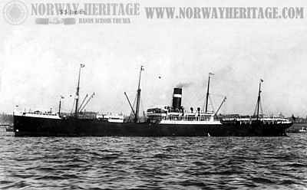
Picture of the S/S Ionian, from an old postcard

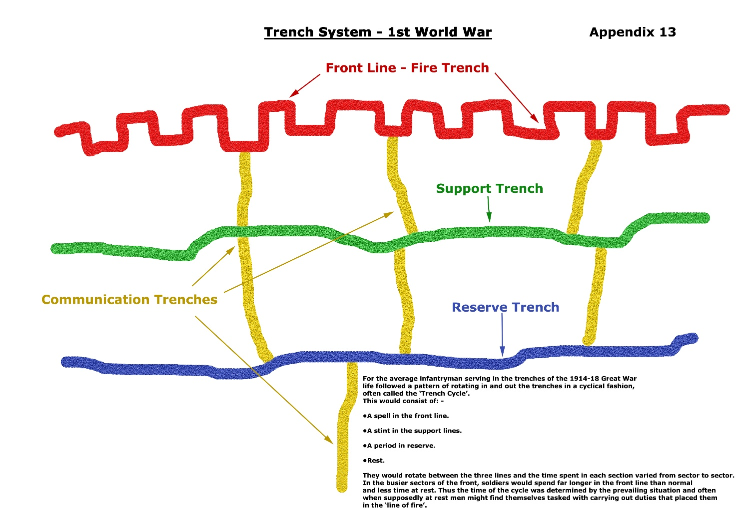
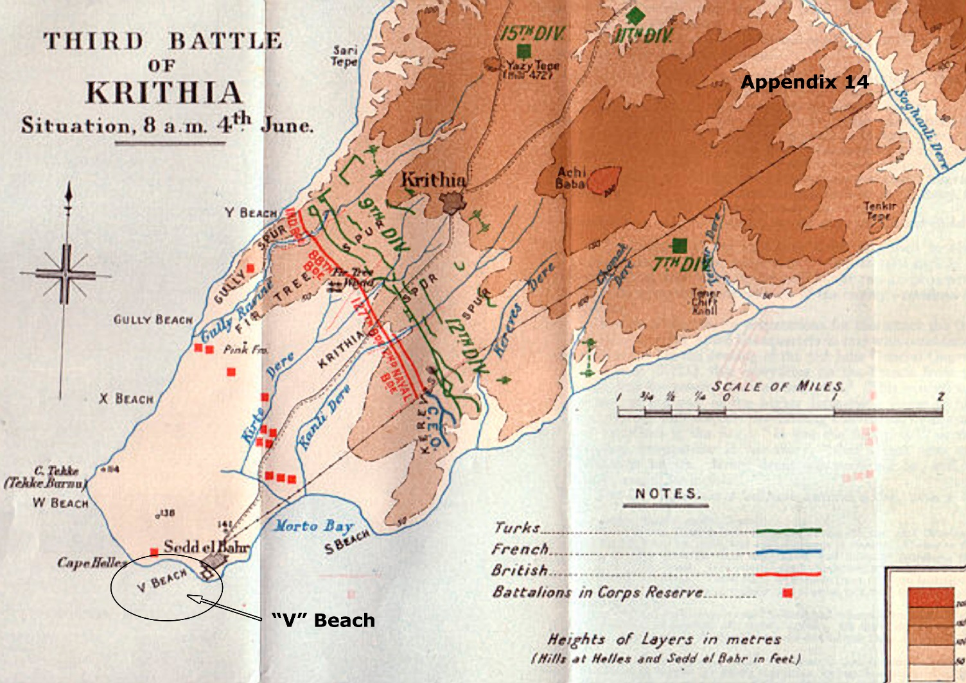
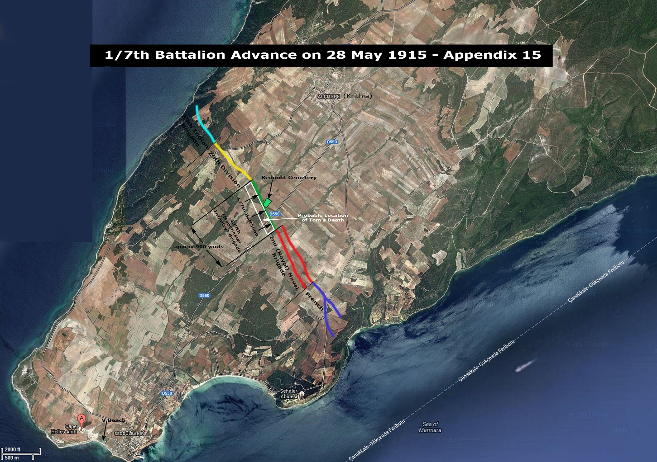

Appendix 17 Timeline

DATE | EVENT | REFERENCE
5 July 1894 | Born | Queen's OTC Records
2 April 1911 | 16 years, Apprentice Linen Manufacturer, residing 204 Shankill Road | 1911 Census of Ireland
7 May 1913 | Joins Belfast University OTC | Queen's OTC Records
13 July 1913 | Attends OTC Camp at Ballykinlar | Original postcard
4 August 1914 | Britain declares war on Germany
2 September 1914 | Commissioned into 1/7th (Territorial) Battalion The Manchester Regiment | - Queen's OTC Records  - The London Gazette 1 September 1914
10 September 1914 | Battalion leaves England - on ship Grantully Castle - 14 transport ships, 1 ammunition ship and HMS Minerva in escort | "The Manchesters in the East"
25 September 1914 | Battalion disembarks at Alexandria, Egypt. Battalion is split - Tom with 1/7th sails to Port Said, and to Sudan via Suez Canal | "The Manchesters in the East"
30 September 1914 | Tom disembarks with 1/7th at Port Sudan. Battalion stationed in Khartoum | "The Manchesters in the East"
5 November 1914 | Britain declares war on Turkey
25 April 1915 | First Allied landings at Gallipoli
16 April 1915 | Tom with part of 1/7th leaves Khartoum by train for Port Sudan | "The Manchesters in the East"
20 April 1915 | Tom with 1/7th embarks on the White Star Liner "The Suvic" bound for Port Suez | "The Manchesters in the East"
22 April 1915 | Arrives Port Suez followed by 8 hour train journey to Cairo and joins with the rest of the Battalion and other units of the East Lancashire Territorial Division, thenceforward called the 42nd Division. Division moves to Alexandria | "The Manchesters in the East"
3 May 1915 | Tom with 1/7th sails from Alexandria on SS Ionian to Gallipoli | "The Manchesters in the East"
7 May 1915 | Tom with 1/7th lands on 'V' Beach, Cape Helles, Gallipoli | - "The Manchesters in the East"  - "I Remain, Your Son Jack"
11 May 1915 | Tom with 1/7th makes long march to front line | - "The Manchesters in the East"  - "I Remain, Your Son Jack"
28 May 1915 | Tom with "D" Company passes from support trenches through front line trenches to dig in 100 - 150 yards forward | - "The Manchesters in the East"  - "I Remain, Your Son Jack"
28/29 May 1915 | Tom is killed in action either on the evening of 28 May or the early hours of 29 May 1915 | - "The Manchesters in the East"  - "I Remain, Your Son Jack"

